**VISVESVARAYA TECHNOLOGICAL UNIVERSITY**

**“JnanaSangama”, Belgaum -590014, Karnataka.**



**LAB REPORT**

**on**

**Object Oriented Java Programming (23CS3PCOOJ)**

***Submitted by***

**ATHARV BORIKAR(1BM23IC015)**

***in partial fulfillment for the award of the degree of***

**BACHELOR OF ENGINEERING**

***in***

**COMPUTER SCIENCE AND ENGINEERING**



**B.M.S. COLLEGE OF ENGINEERING**

**(Autonomous Institution under VTU)**

**BENGALURU-560019**

**Sep-2024 to Jan-2025**

**B.M.S. College of Engineering,**

**Bull Temple Road, Bangalore 560019**

(Affiliated To Visvesvaraya Technological University, Belgaum)

**Department of Computer Science and Engineering**



**CERTIFICATE**

This is to certify that the Lab work entitled “Object Oriented Java Programming (23CS3PCOOJ)” carried out by **ATHARV BORIKAR (1BM23IC015),** who is bonafide student of **B.M.S. College of Engineering.** It is in partial fulfillment for the award of **Bachelor of Engineering in Computer Science and Engineering** of the Visvesvaraya Technological University, Belgaum. The Lab report has been approved as it satisfies the academic requirements in respect of an Object Oriented Java Programming (23CS3PCOOJ) work prescribed for the said degree.

|  |  |
| --- | --- |
| Dr. Seema Patil  Assistant Professor  Department of CSE, BMSCE | Dr. Jyothi S Nayak  Professor & HOD  Department of CSE, BMSCE |

**Index**

|  |  |  |  |
| --- | --- | --- | --- |
| **Sl.**  **No.** | **Date** | **Experiment Title** | **Page No.** |
| 1 | 28/10/24 | Implement Quadratic Equation | 4 |
| 2 | 04/11/24 | SGPA Calculation | 7 |
| 3 | 11/11/24 | Display Book Details | 12 |
| 4 | 11/11/24 | Using Abstract Class Shape | 15 |
| 5 | 18/11/24 | Bank Account Storage | 19 |
| 6 | 18/11/24 | Creating Packages CIE and SEE | 27 |
| 7 | 28/11/24 | Handling Exceptions in Inheritance Tree | 34 |
| 8 | 28/11/24 | Threads Creation | 38 |
| 9 | 28/11/24 | User Interface Creation | 41 |
| 10 | 28/11/24 | Demonstrating IPC and Deadlock | 43 |

Github Link:

<https://github.com/Ath007-dev/Lab-Programs>

**Program 1**

Implement Quadratic Equation

**Algorithm:**

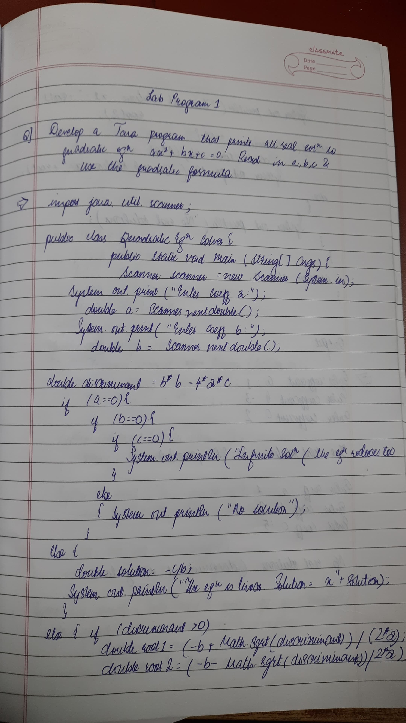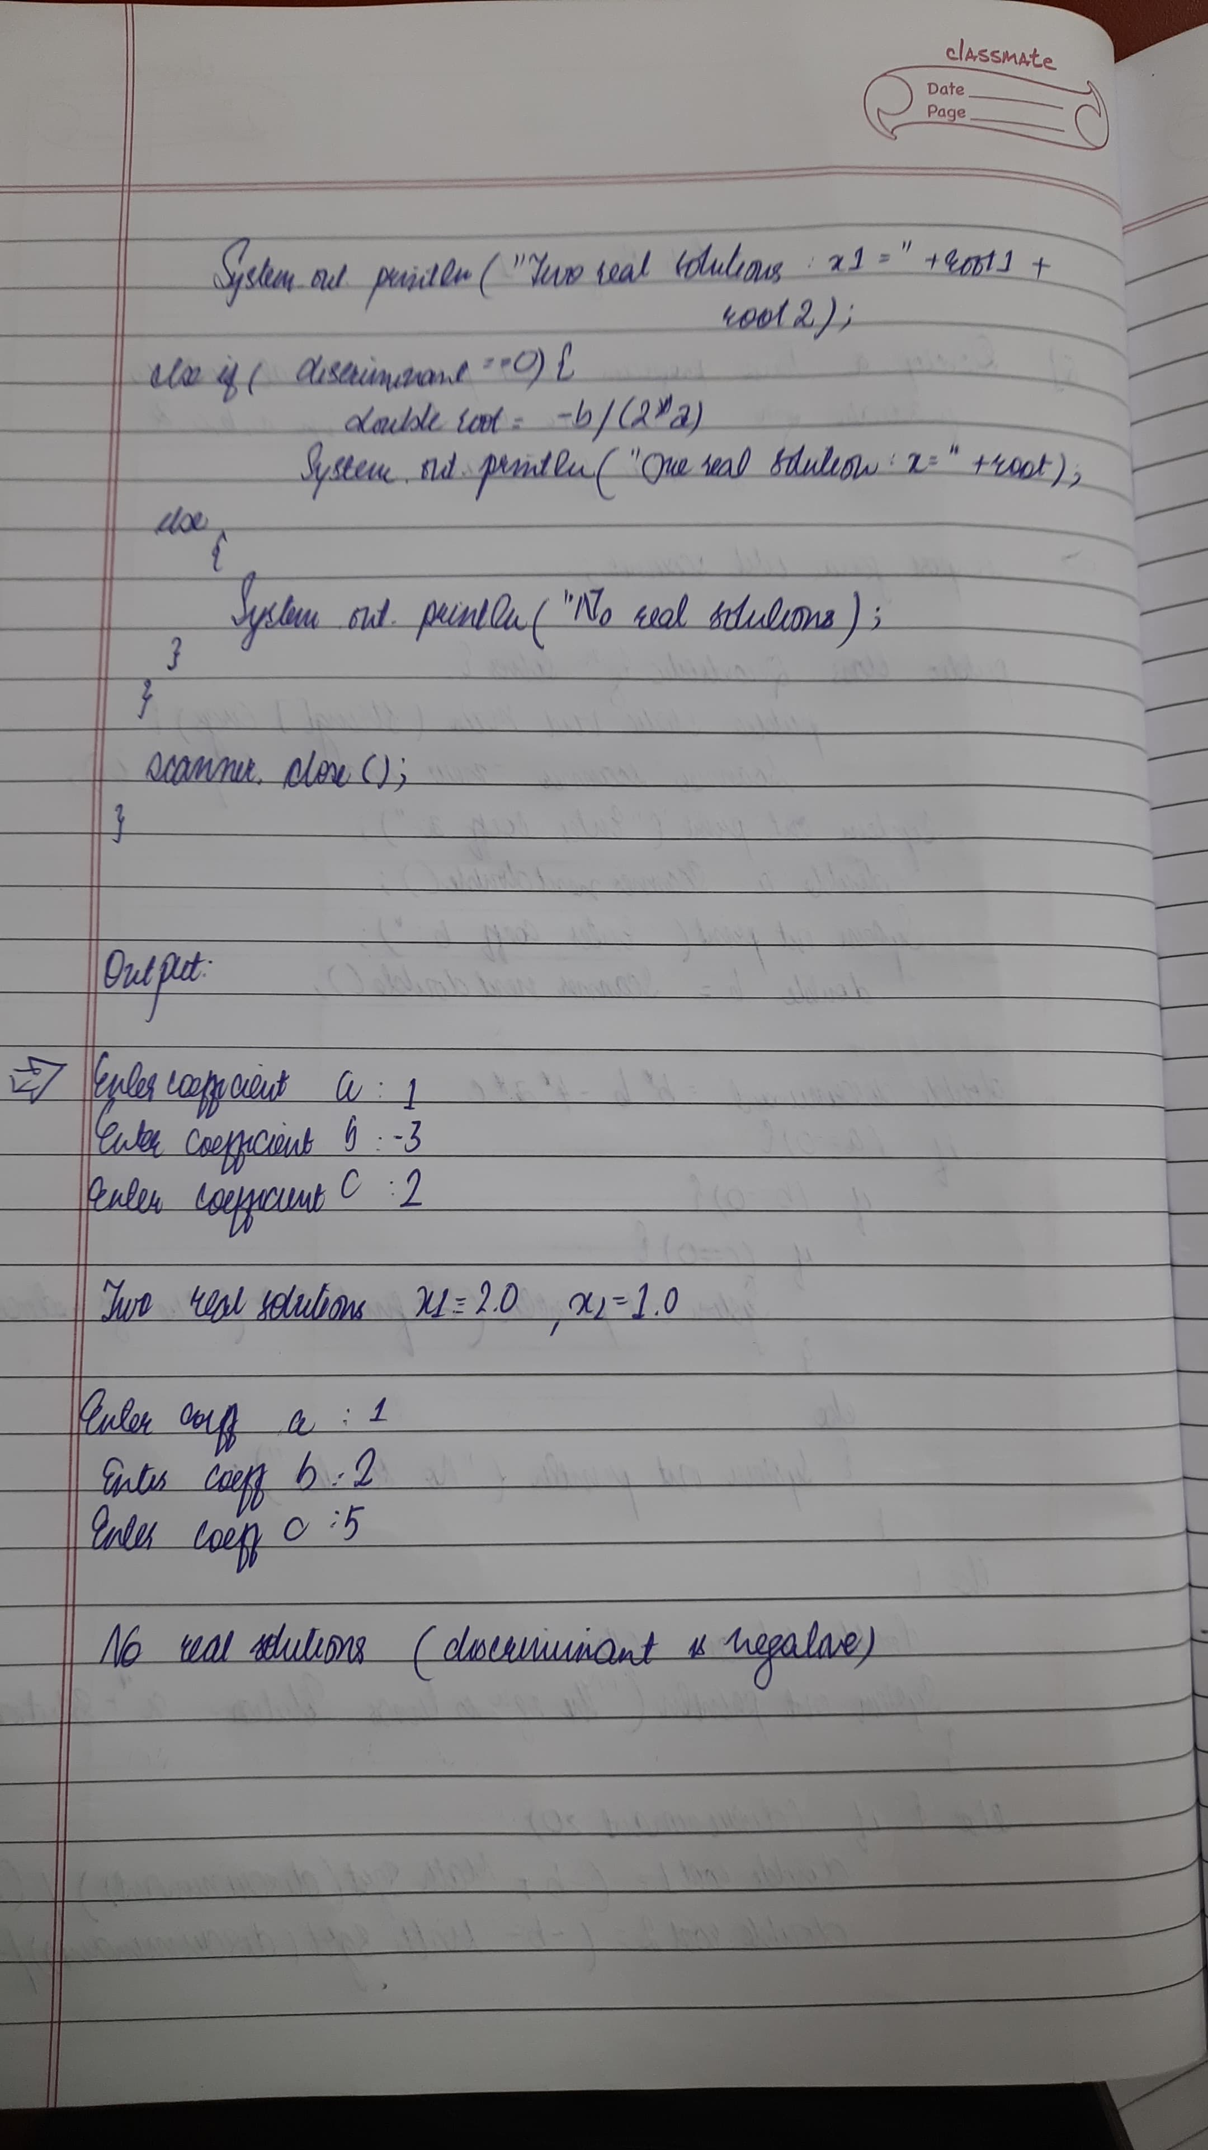

**Code:**

import java.util.Scanner;

class Quadratic

{ int a, b, c;

double r1, r2, d;

void getd()

{

Scanner s = new Scanner(System.in);

System.out.println("Enter the coefficients of a,b,c");

a = s.nextInt(); b = s.nextInt(); c = s.nextInt();

}

void compute()

{

while(a==0)

{

System.out.println("Not a quadratic equation");

System.out.println("Enter a non zero value for a:");

Scanner s = new Scanner(System.in);

a = s.nextInt();

}

d = b*b-4*a*c;

if(d==0)

{

r1 = (-b)/(2*a);

System.out.println("Roots are real and equal");

System.out.println("Root1 = Root2 = " + r1);

}

else if(d>0)

{

r1 = ((-b)+(Math.sqrt(d)))/(double)(2*a);

r2 = ((-b)-(Math.sqrt(d)))/(double)(2*a);

System.out.println("Roots are real and distinct");

System.out.println("Roo1 = " + r1 + " Root2 = " + r2);

}

else if(d<0)

{

System.out.println("Roots are imaginary");

r1 = (-b)/(2*a);

r2 = Math.sqrt(-d)/(2*a);

System.out.println("Root1 = " + r1 + " + i"+r2);

System.out.println("Root1 = " + r1 + " - i"+r2);

}

}

}

class QuadraticMain

{

public static void main(String args[])

{

Quadratic q = new Quadratic();

q.getd();

q.compute();

}

}

**Program 2**

SGPA Calculation

**Algorithm:**

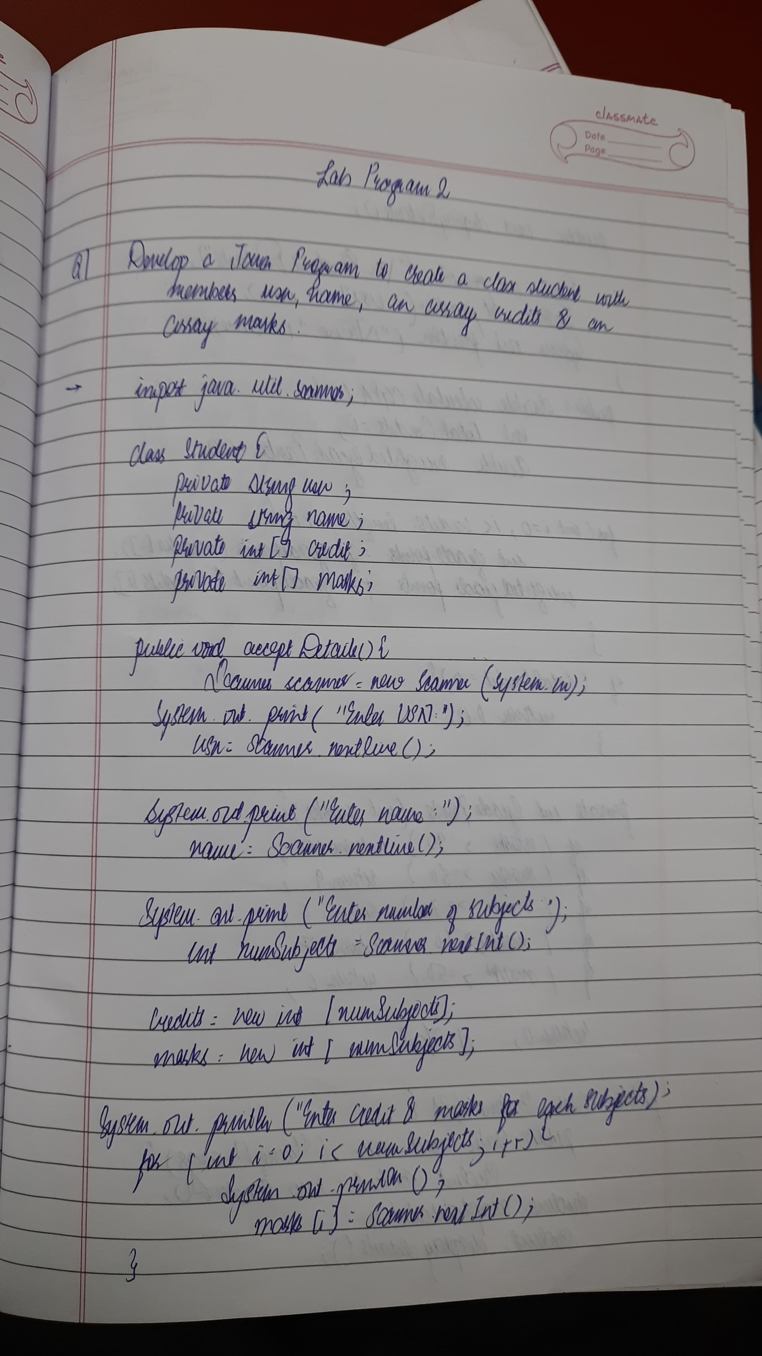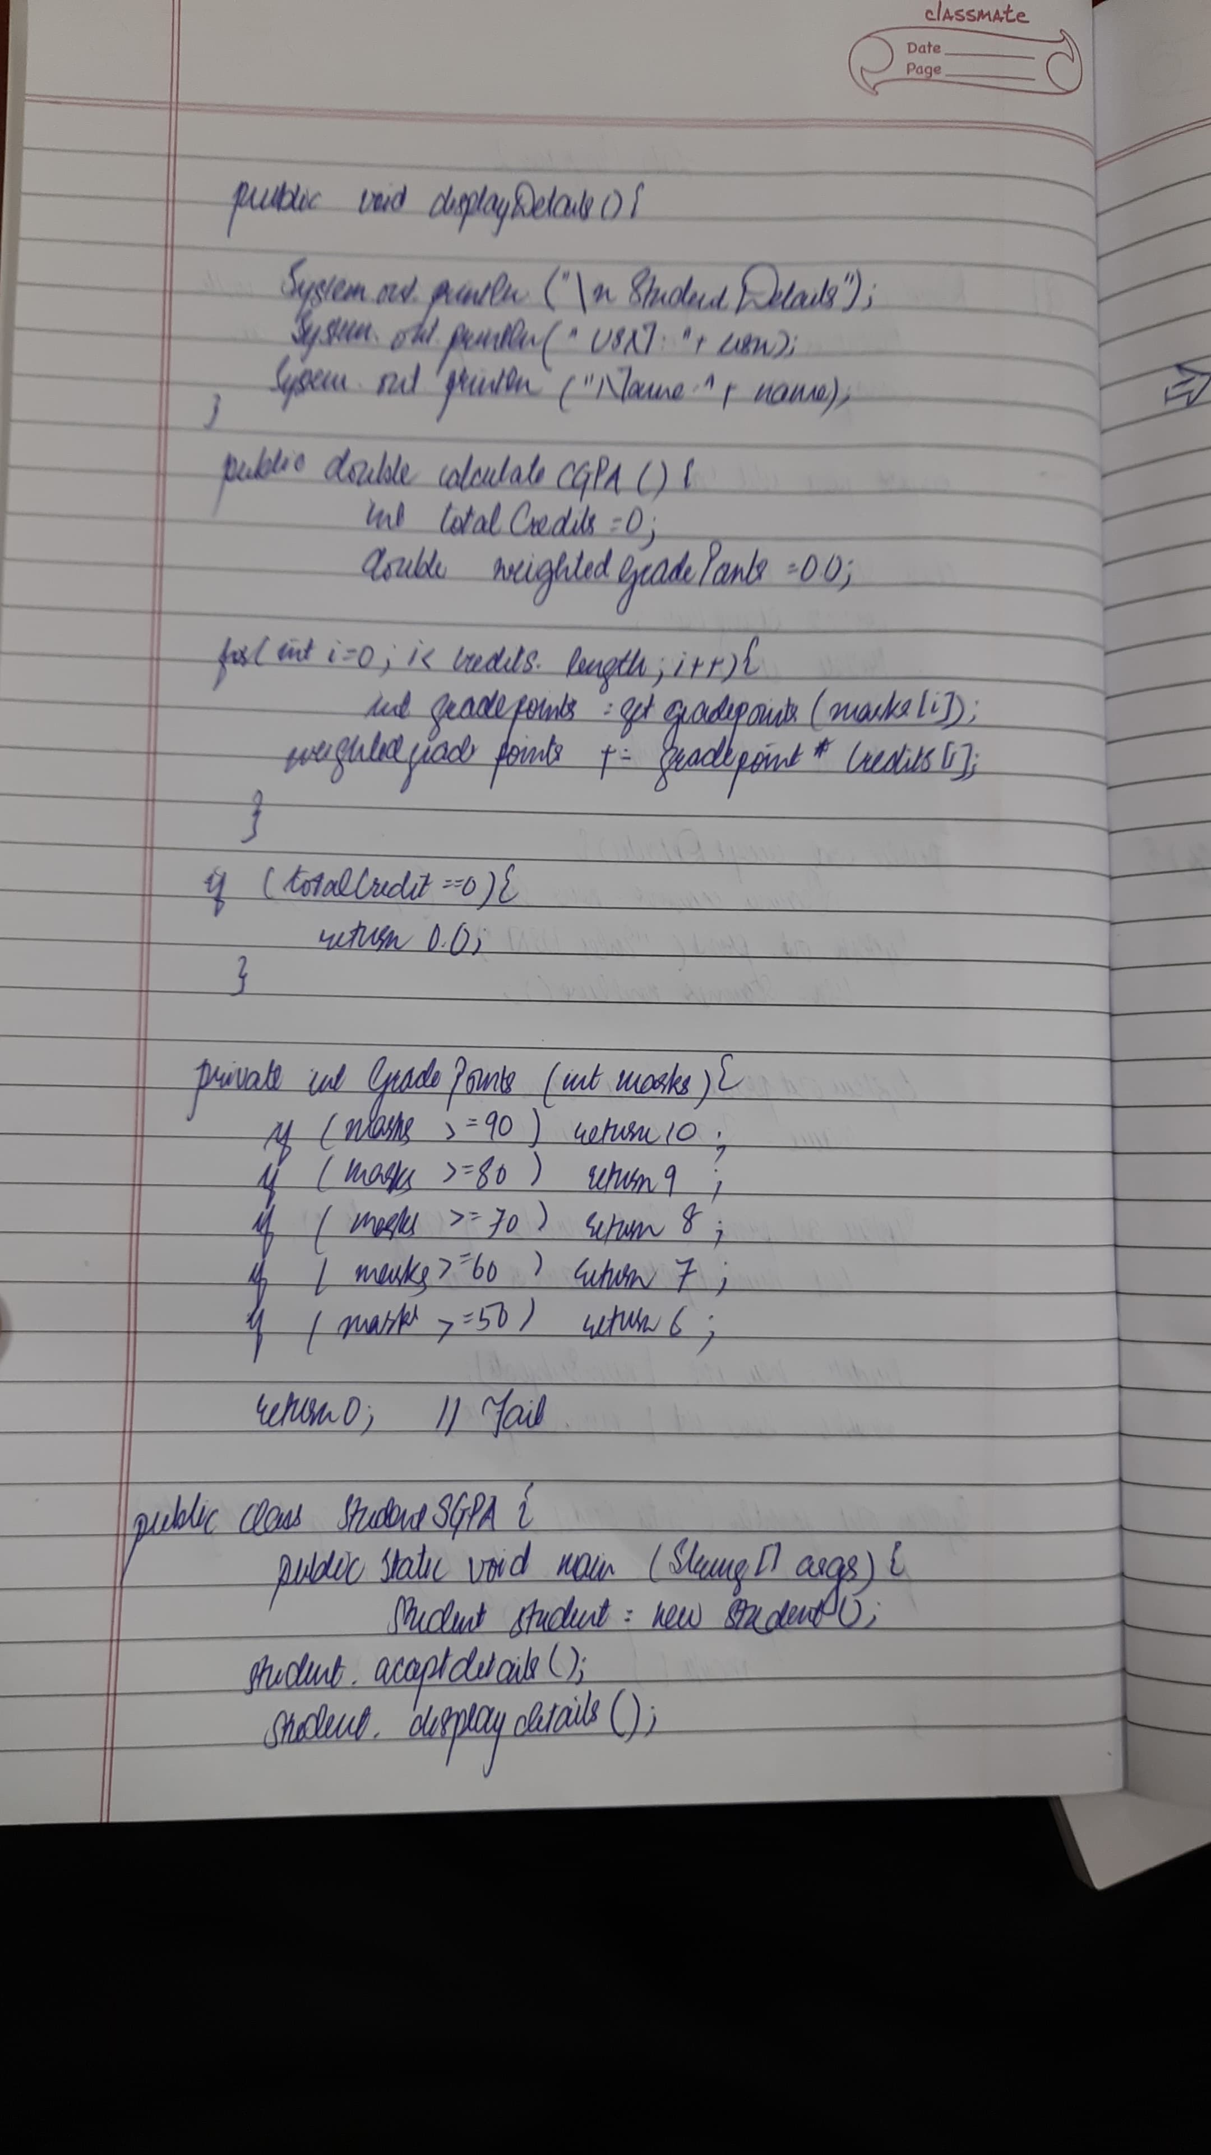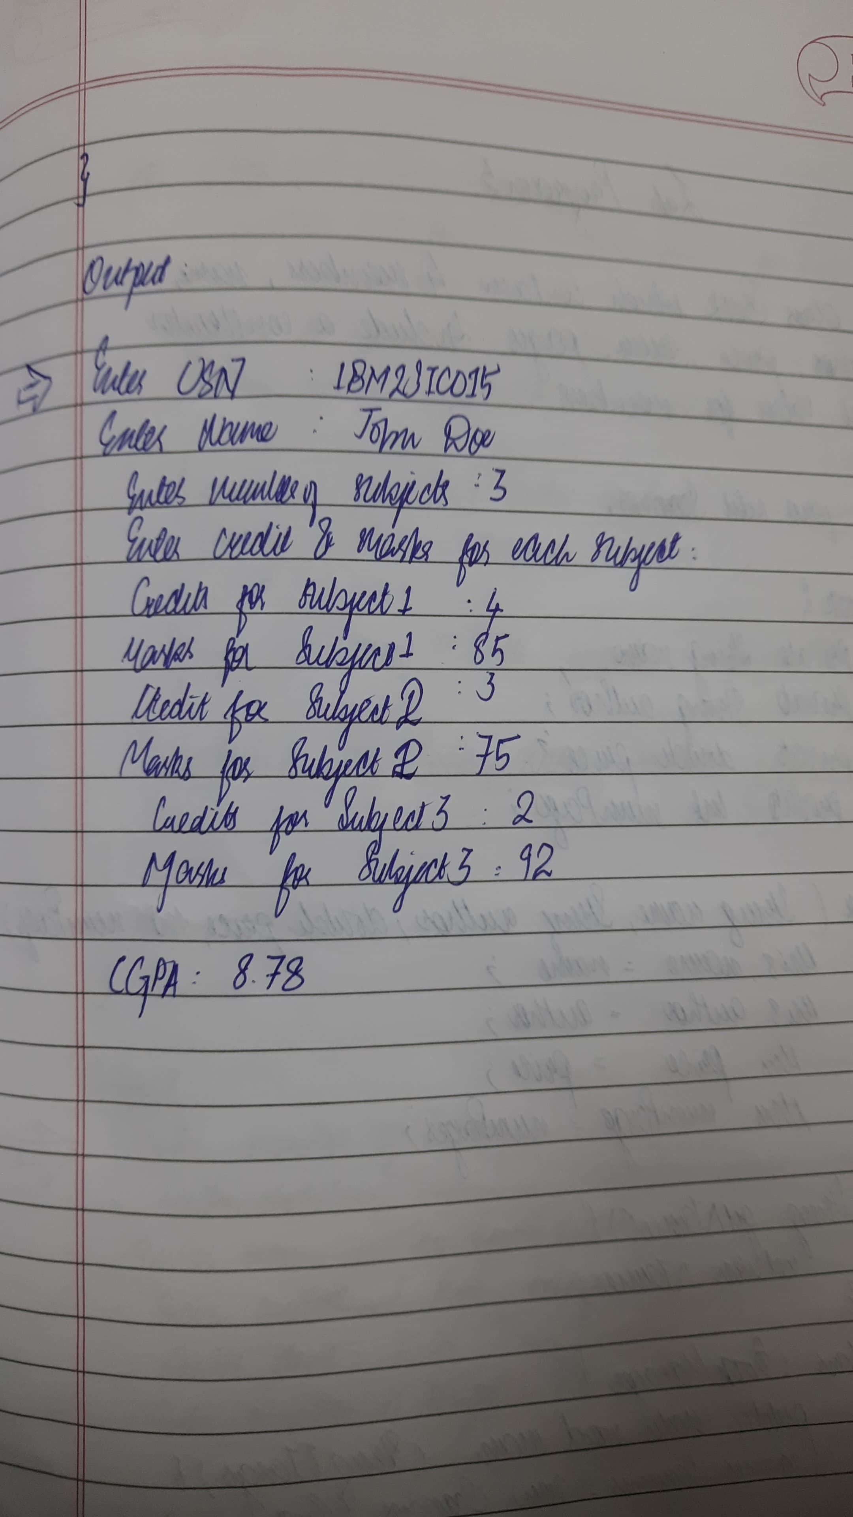

**Code:**

import java.util.Scanner;

class Subject

{

int subjectMarks;

int credits;

int grade;

}

class Student

{

Subject subject[];

String name;

String usn;

double SGPA;

Scanner s;

Student()

int i;

subject = new Subject[9];

for(i=0;i<9;i++)

subject[i] = new Subject();

s = new Scanner(System.in);

}

void getStudentDetails()

{

System.out.print("Enter your Name: ");

name = s.next();

System.out.print("Enter your USN: ");

usn = s.next();

}

void getMarks()

{

for(int i=0;i<9;i++)

{

System.out.print("Enter marks for subject "+(i+1)+" :");

subject[i].subjectMarks = s.nextInt();

System.out.print("Enter credits for subject "+(i+1)+" :");

subject[i].credits = s.nextInt();

subject[i].grade = (subject[i].subjectMarks/10) + 1;

if(subject[i].grade==11)

subject[i].grade = 10;

if(subject[i].grade<=4)

subject[i].grade = 0;

}

}

void computeSGPA()

{

int effectiveScore = 0;

int totalCredits = 0;

for(int i=0;i<9;i++)

{

effectiveScore += (subject[i].grade*subject[i].credits);

totalCredits += subject[i].credits;

}

SGPA = (double)effectiveScore/(double)totalCredits;

}

}

class Student_SGPA

{

public static void main(String args[])

{

Student s1 = new Student();

s1.getStudentDetails();

s1.getMarks();

s1.computeSGPA();

System.out.println("Name: "+s1.name);

System.out.println("USN: "+s1.usn);

System.out.println("SGPA: "+s1.SGPA);

}

}

**Program 3**

Display Book Details

**Algorithm:**

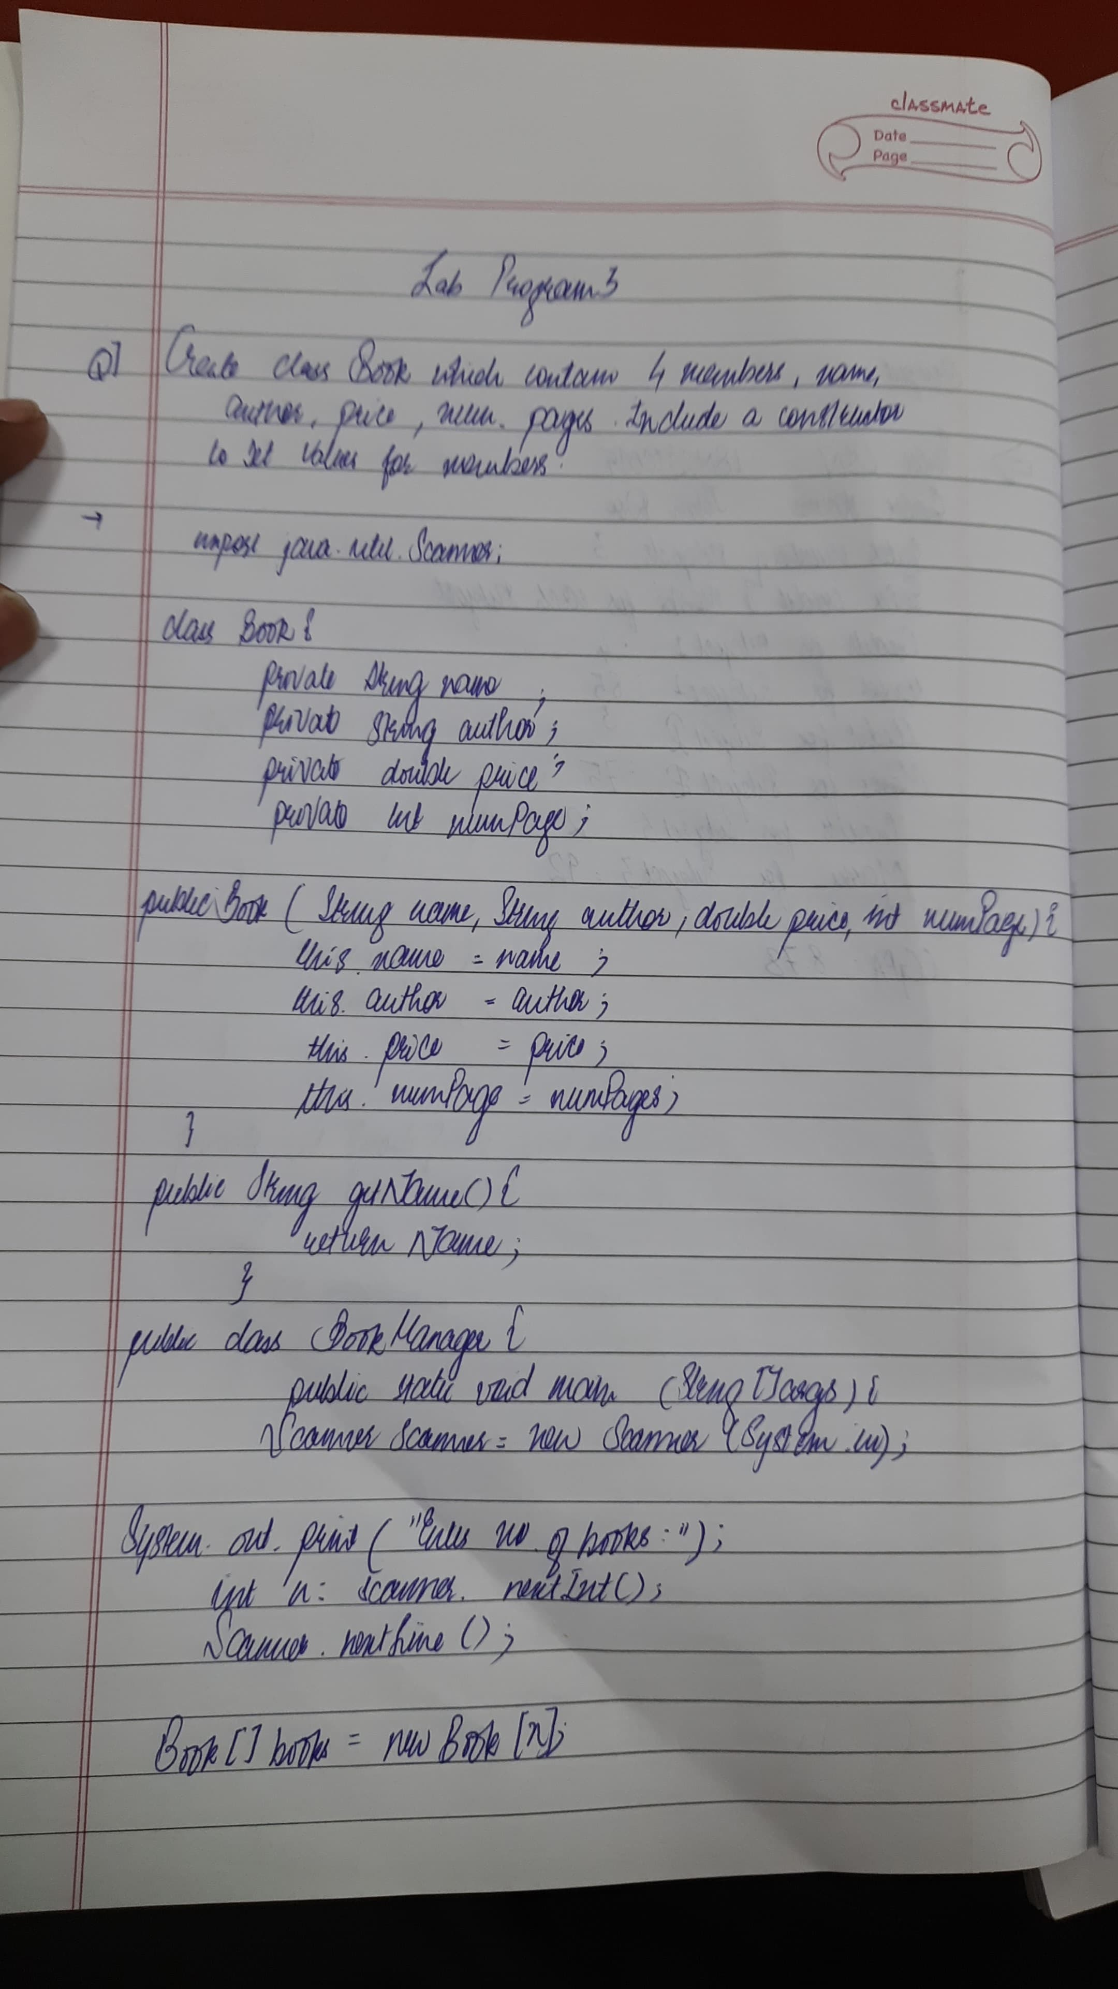

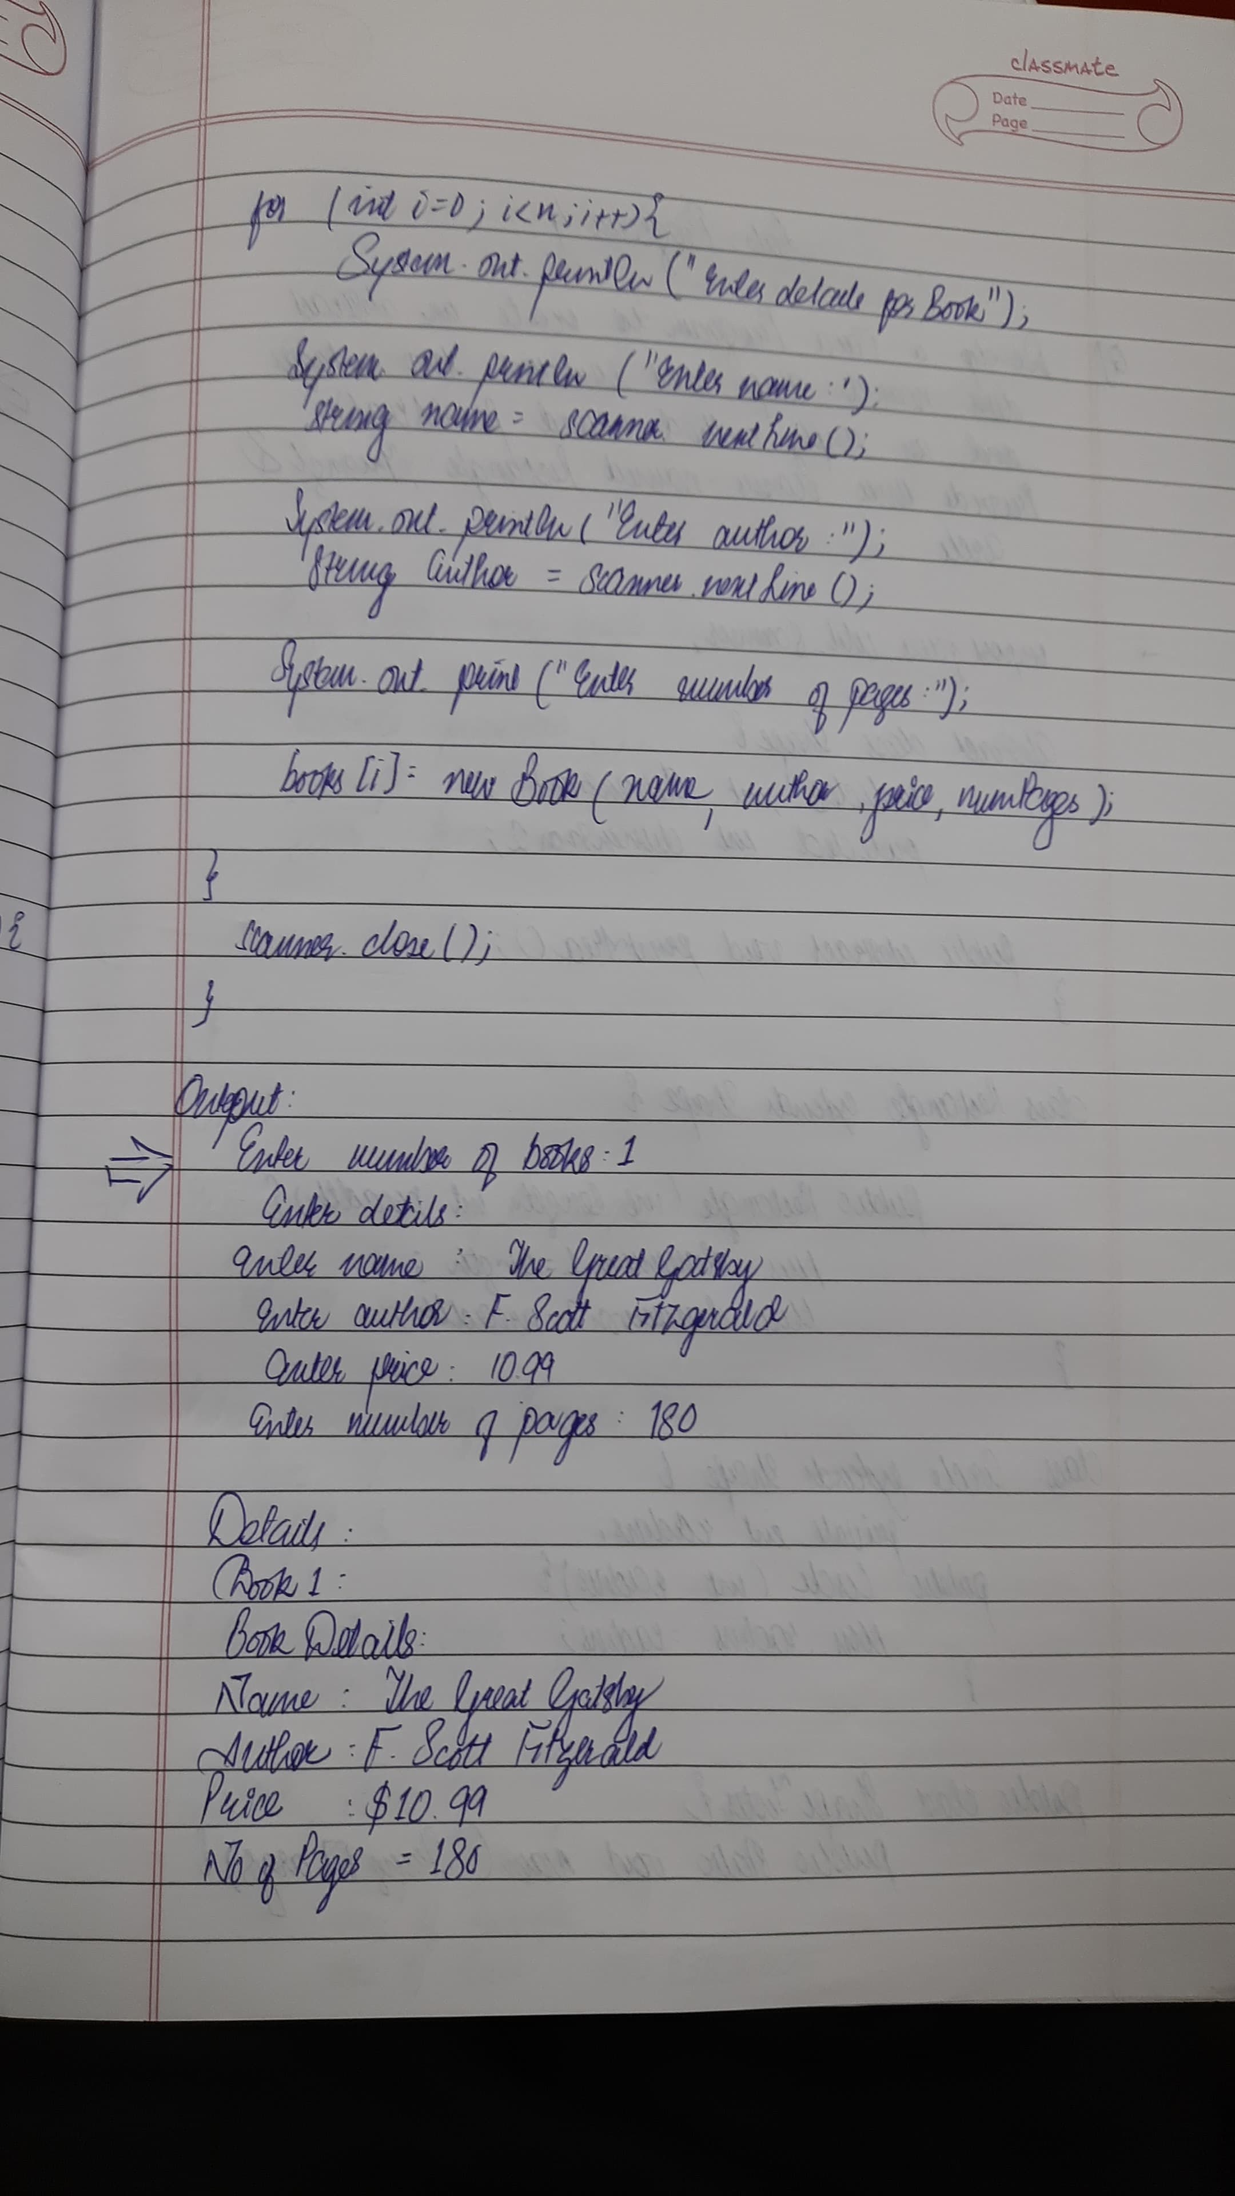

**Code:**

import java.util.Scanner ;

class Main{

public static void main(String args[]){

int n ;

System.out.print("Enter the number of books:") ;

Scanner sc = new Scanner(System.in) ; n = sc.nextInt() ;

sc.nextLine() ;

Book books[] = new Book[n];

for(int i = 0 ; i<n ; i++){

System.out.print("Enter the book name: ") ;

String name = sc.nextLine() ;

System.out.print("Enter the author name: ") ;

String author = sc.nextLine() ;

System.out.print("Enter the price of the book: ") ;

int price = sc.nextInt() ;

System.out.print("Enter the number of pages in the book: ") ;

int numPages = sc.nextInt() ;

sc.nextLine() ;

books[i] = new Book(name,author,price,numPages) ;

}

System.out.println("");

for(int i = 0 ; i<n ; i++){

System.out.println(books[i].toString()) ;

}

System.out.println("ATHARV BORIKAR" ) ;

System.out.print("1BM23IC015") ;

sc.close();

}

}

class Book{

String name , author ;

int price , numPages ;

Book(String name , String author , int price , int numPages){

this.name = name ;

this.author = author ;

this.price = price ;

this.numPages = numPages ;

}

public String toString(){

String name ,author , price,numPages ;

name = "Book name: " + this.name + "\n" ;

author = "Author name: " + this.author + "\n" ;

price = "Price: " + this.price + "\n" ;

numPages = "Number of pages: " + this.numPages + "\n" ;

return name + author + price + numPages ;

}

}

**Program 4**

Using Abstract Class Shape

**Algorithm:**

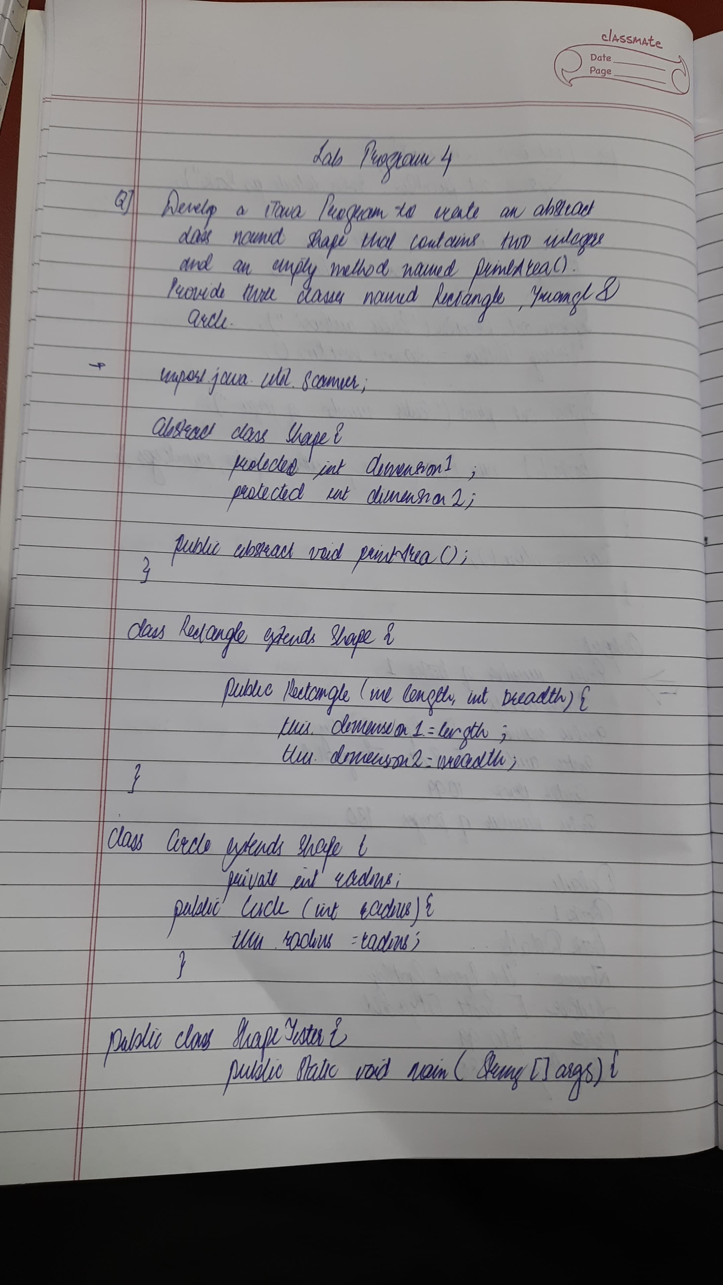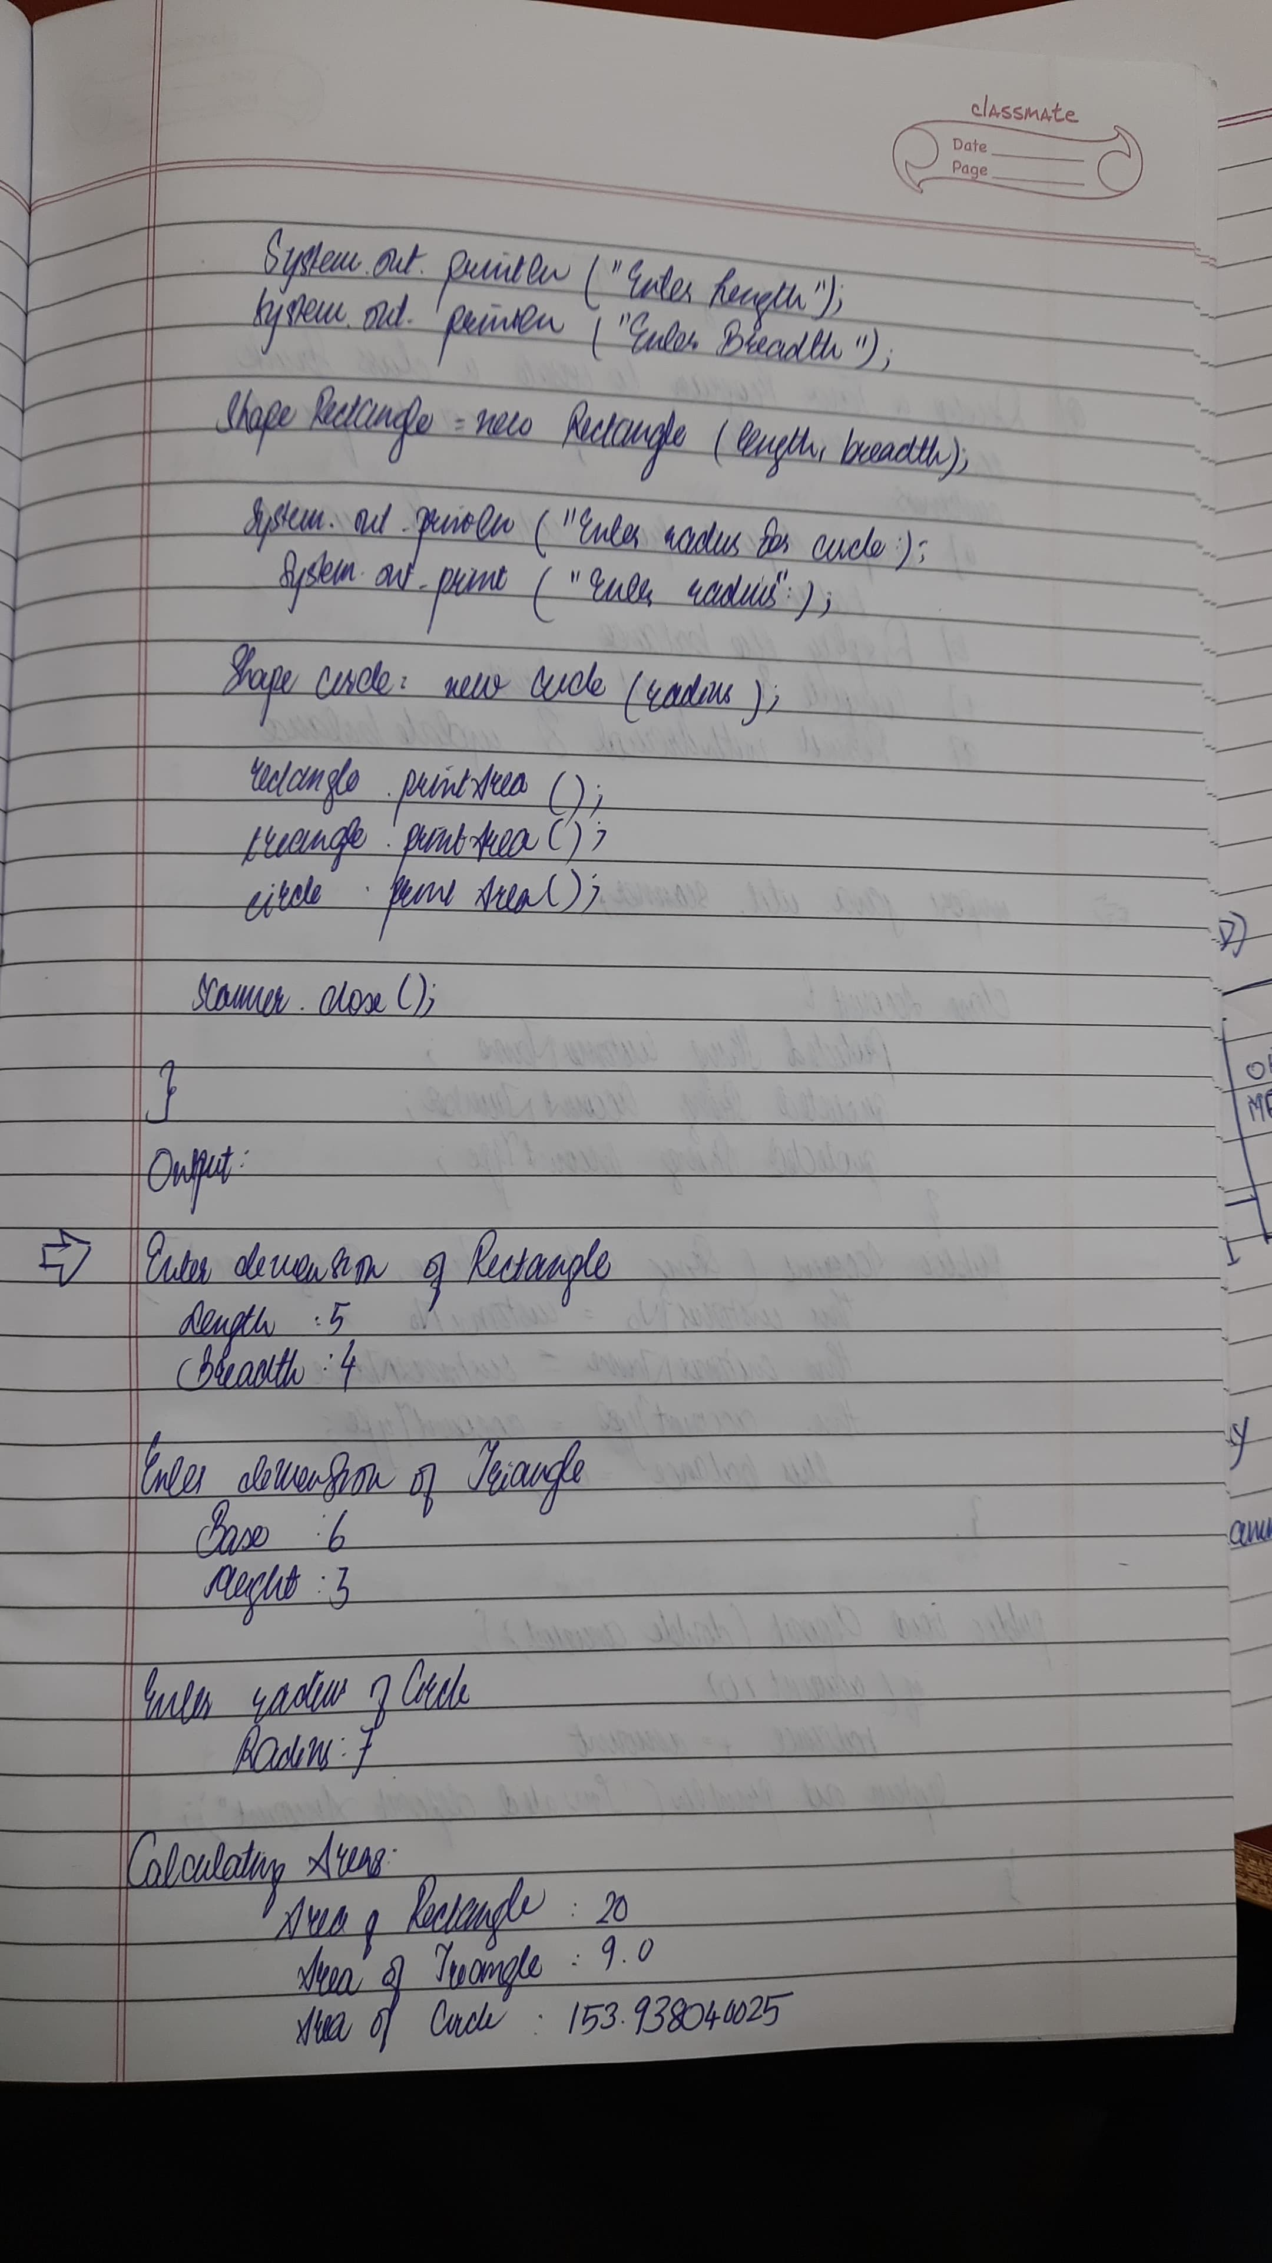

**Code:**

import java.util.Scanner ;

class Main{

public static void main(String[] args){

Rectangle ob2 = new Rectangle() ;

Triangle ob1 = new Triangle() ;

Circle ob3 = new Circle() ;

ob2.printArea() ;

ob1.printArea() ;

ob3.printArea() ;

System.out.println("ATHARV BORIKAR " ) ;

System.out.print("1BM23IC015") ;

}

}

abstract class Shape{

Scanner sc = new Scanner(System.in) ;

int dimension1 , dimension2 ;

abstract void printArea();

}

class Rectangle extends Shape{

Rectangle(){

System.out.println("Enter the dimensions of the rectangle(Length and Breadth): " ) ;

dimension1 = sc.nextInt() ;

dimension2 = sc.nextInt() ;

}

void printArea(){

System.out.print("The area of the rectangle is = ") ;

System.out.println(dimension1*dimension2) ;

}

}

class Triangle extends Shape{

Triangle(){

System.out.println("Enter the dimensions of the triangle(base and height): " ) ;

dimension1 = sc.nextInt() ;

dimension2 = sc.nextInt() ;

}

void printArea(){

System.out.print("The area of the Triangle is = ") ;

System.out.println(0.5*dimension1*dimension2) ;

}

}

class Circle extends Shape{

Circle(){

System.out.println("Enter the dimension of the circle(radius): ") ;

dimension1 = sc.nextInt() ;

}

void printArea(){

System.out.print("The area of the Circle is = ") ;

System.out.println(3.1415926535897*dimension1*dimension1) ;

}

}

**Program 5**

Bank Account Storage

**Algorithm:**

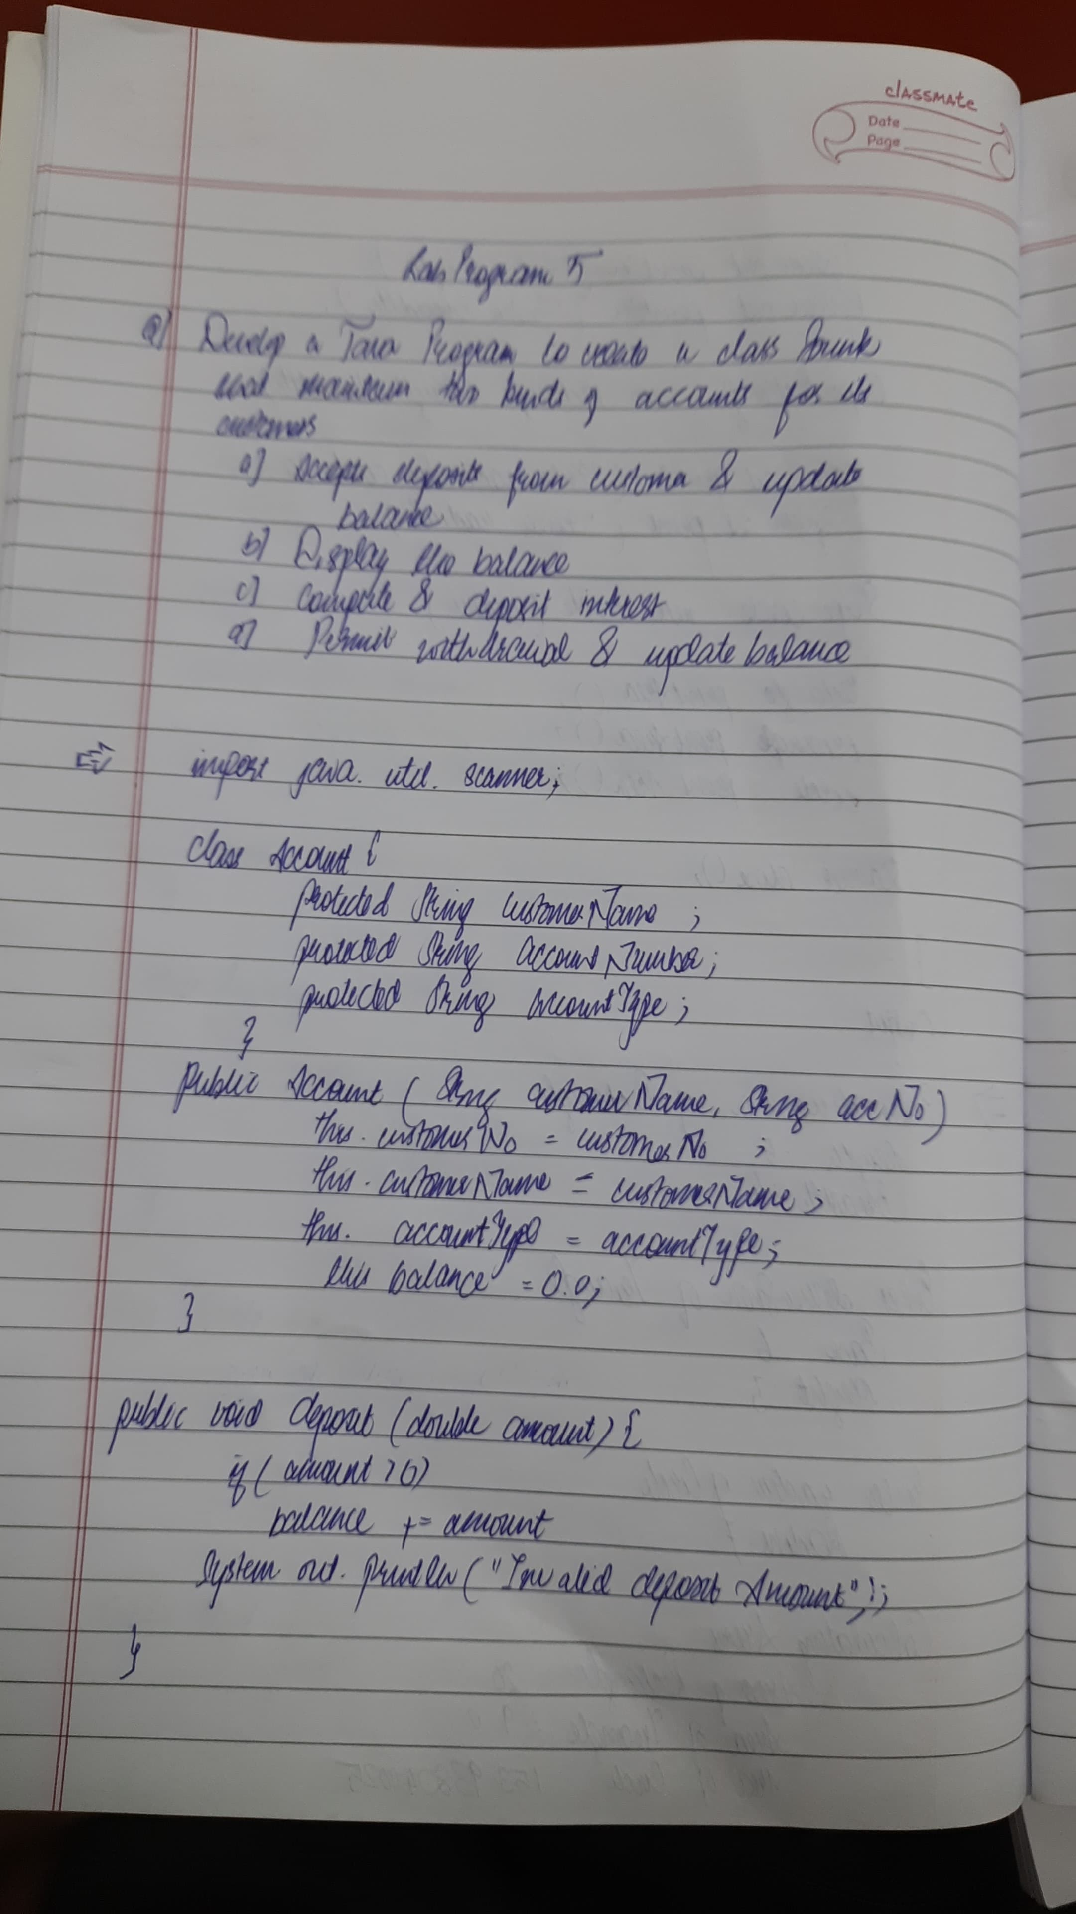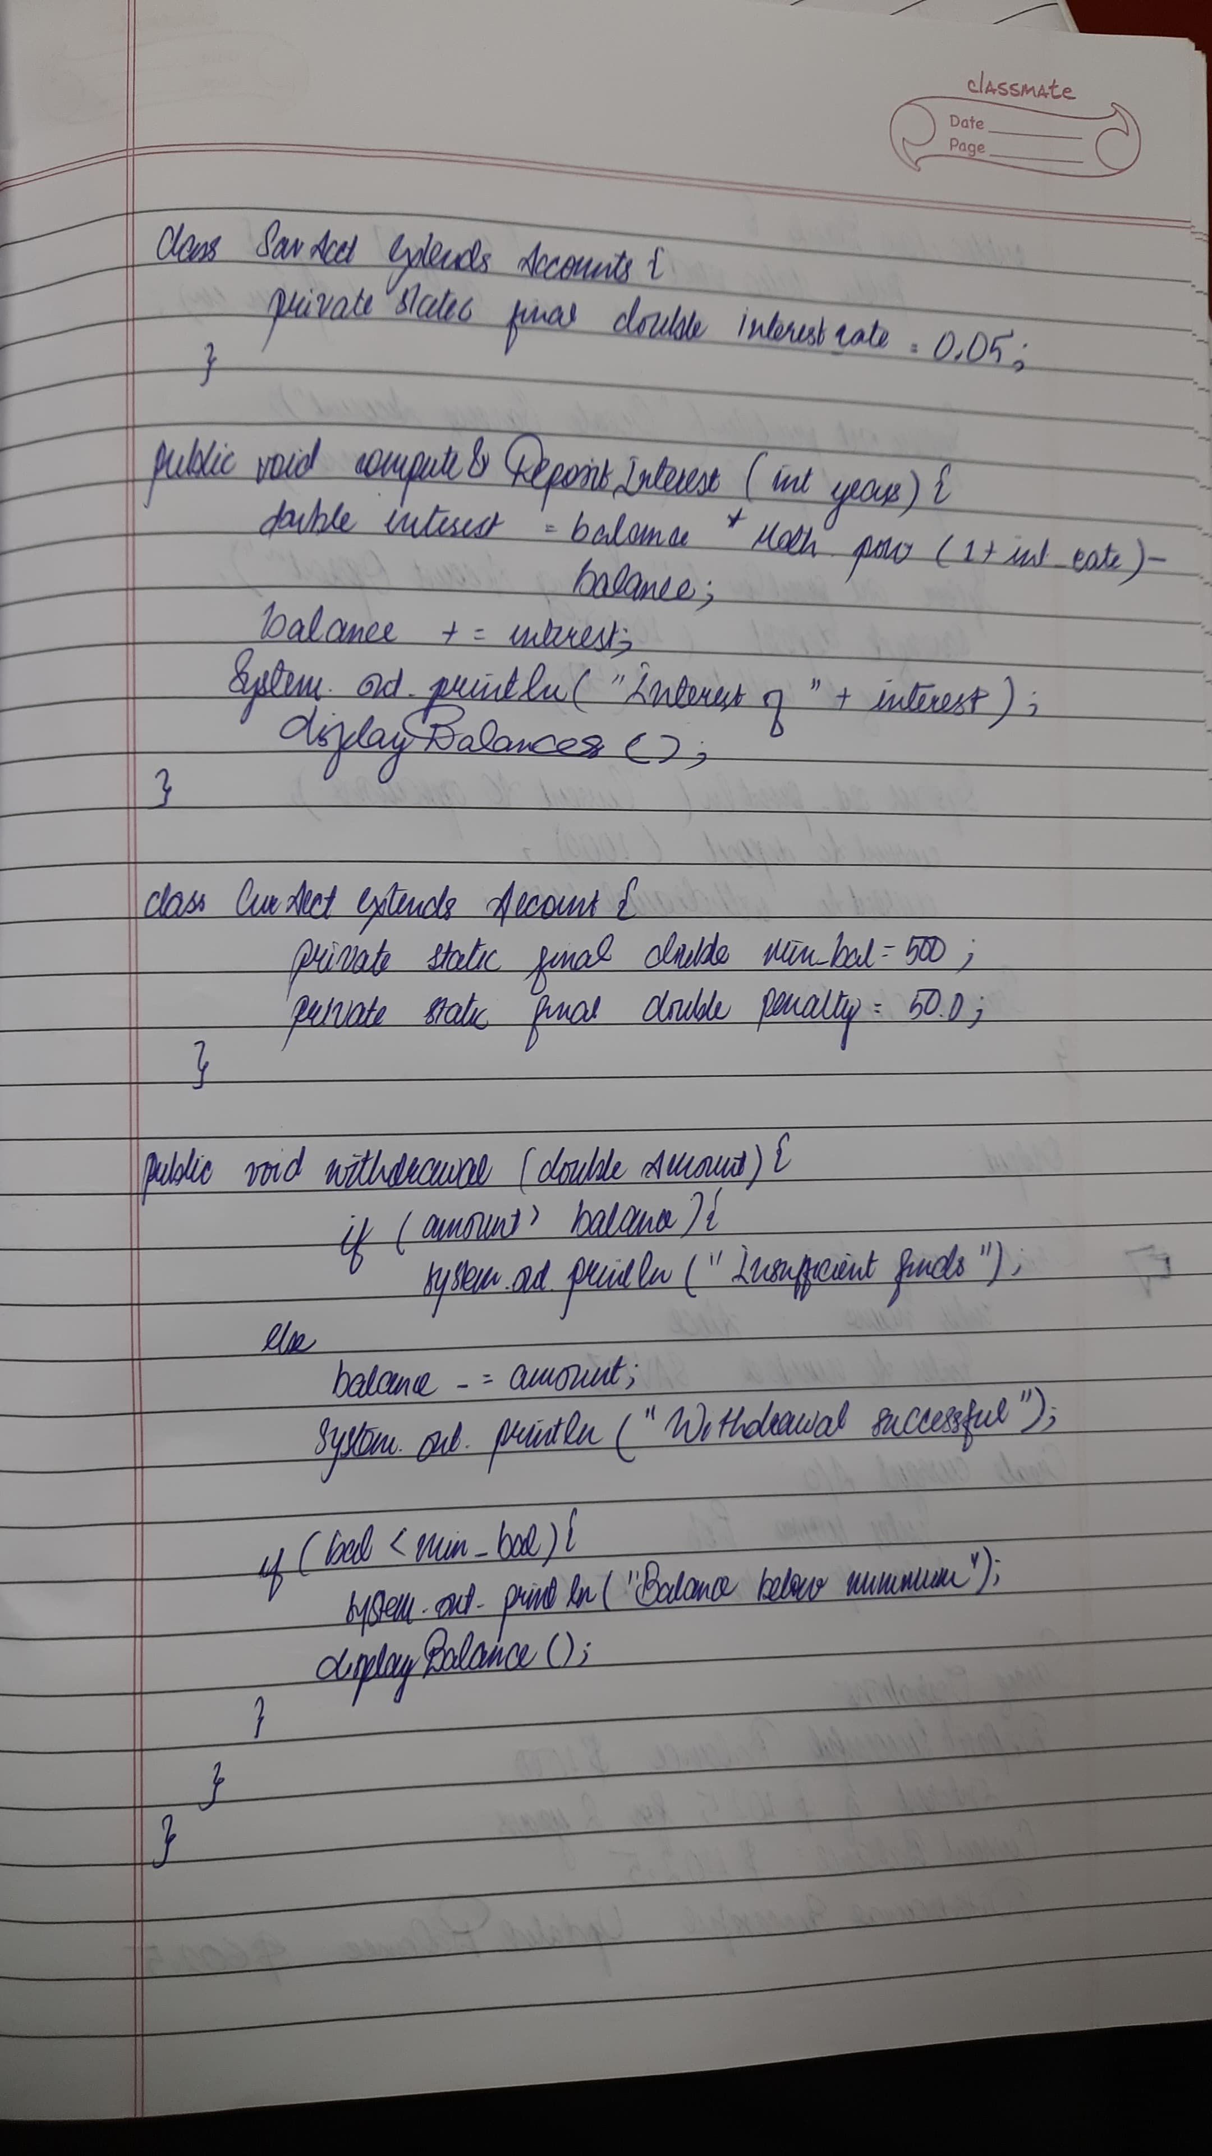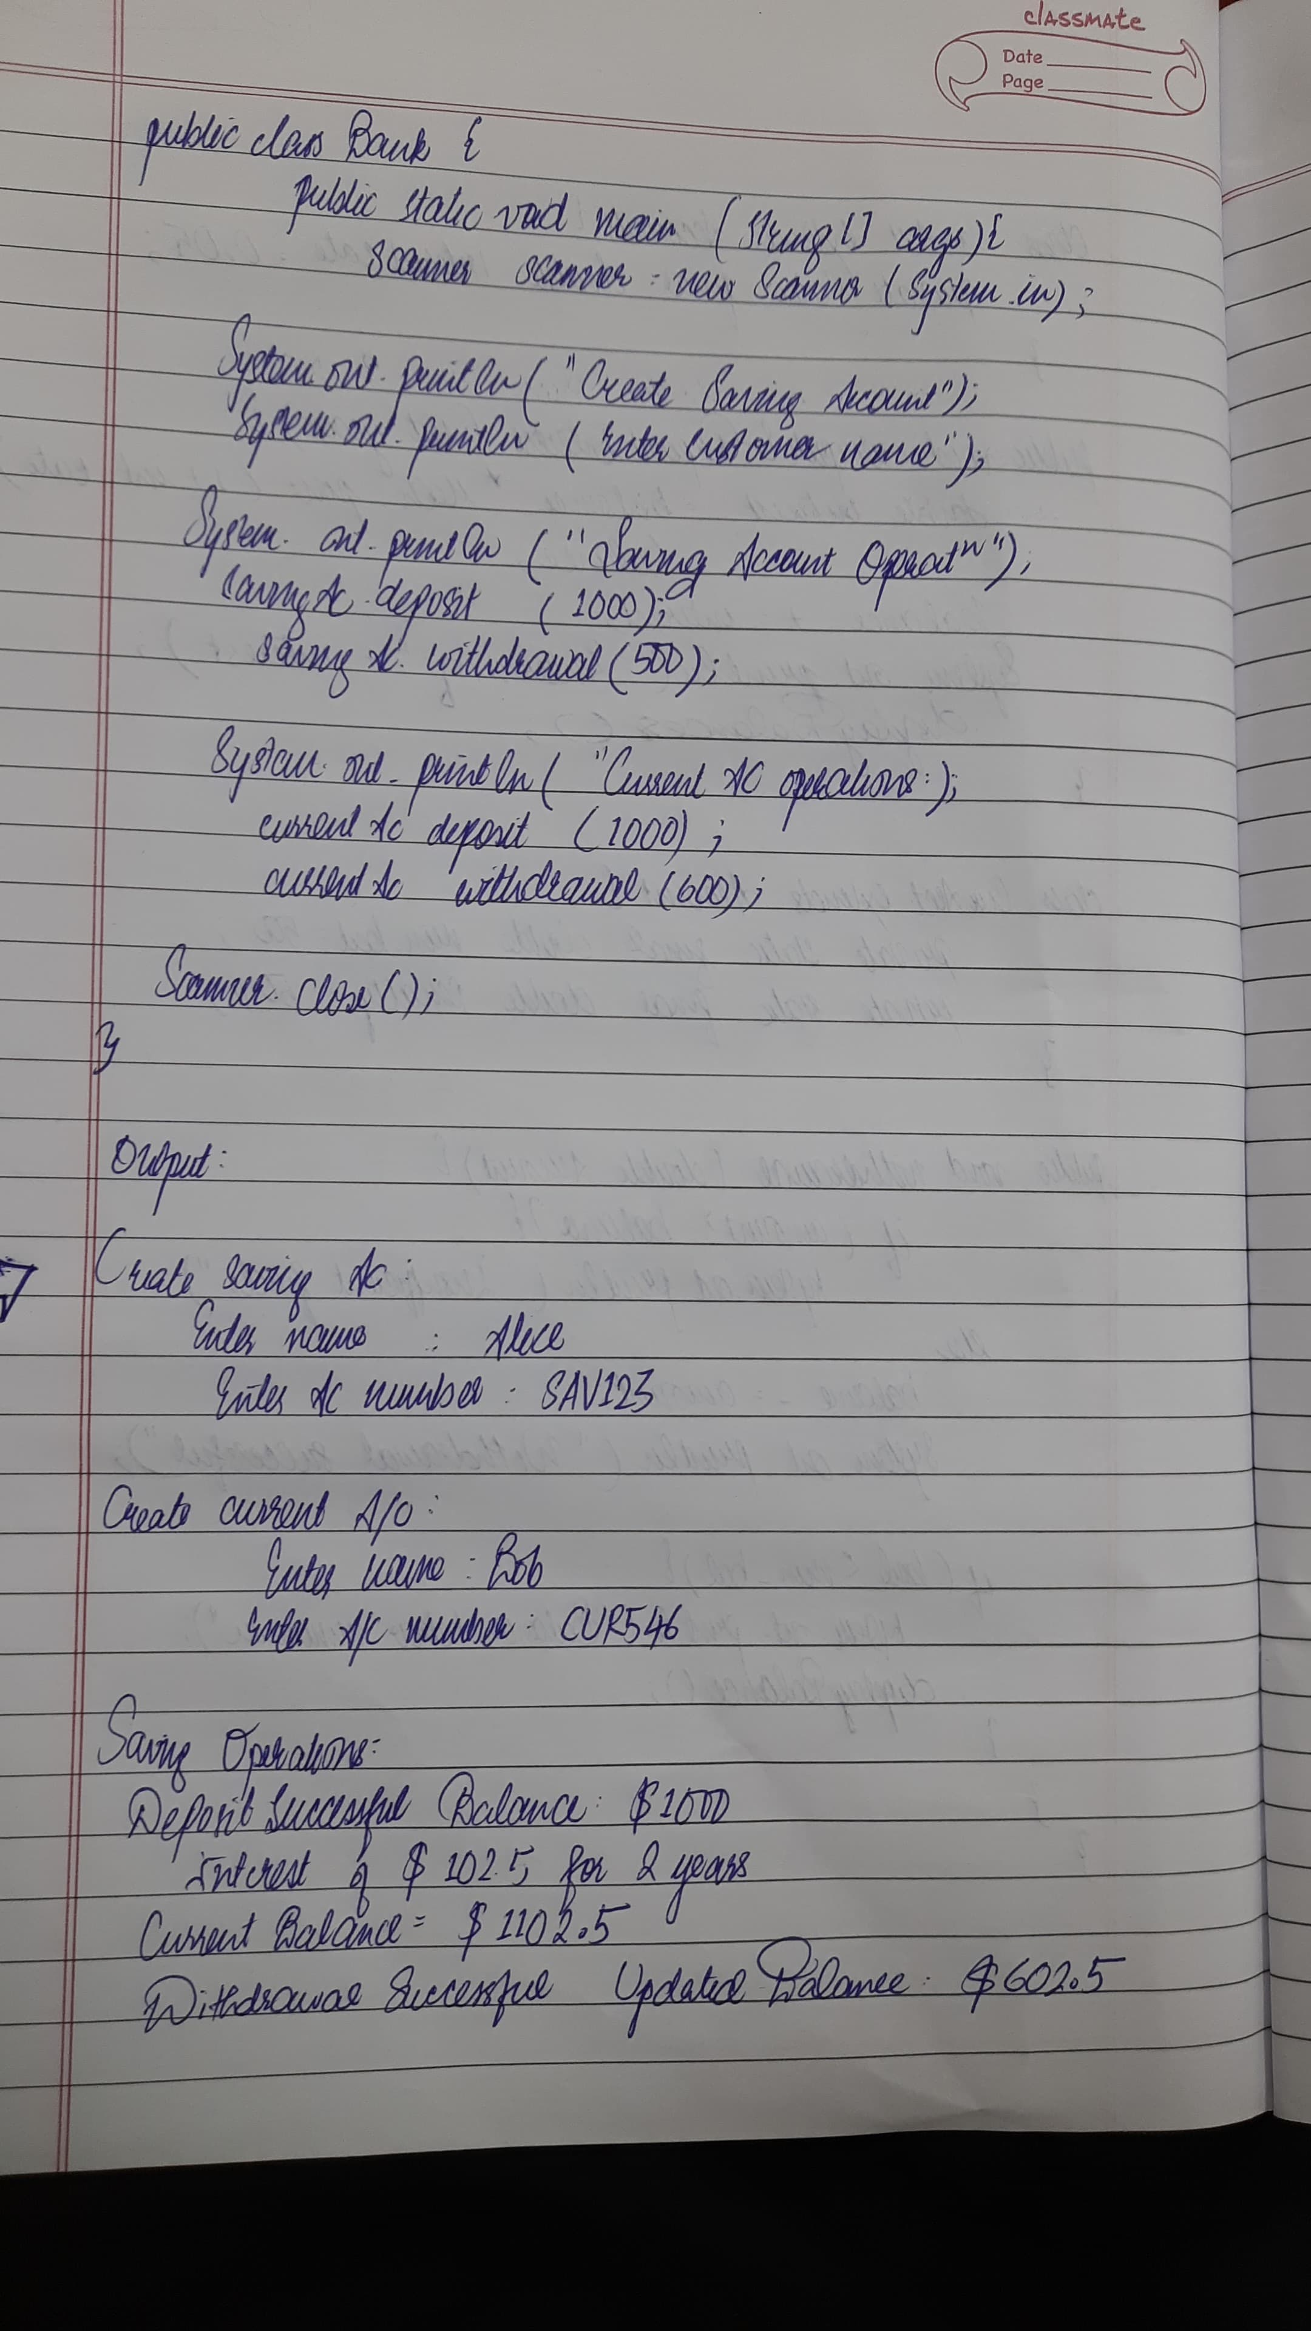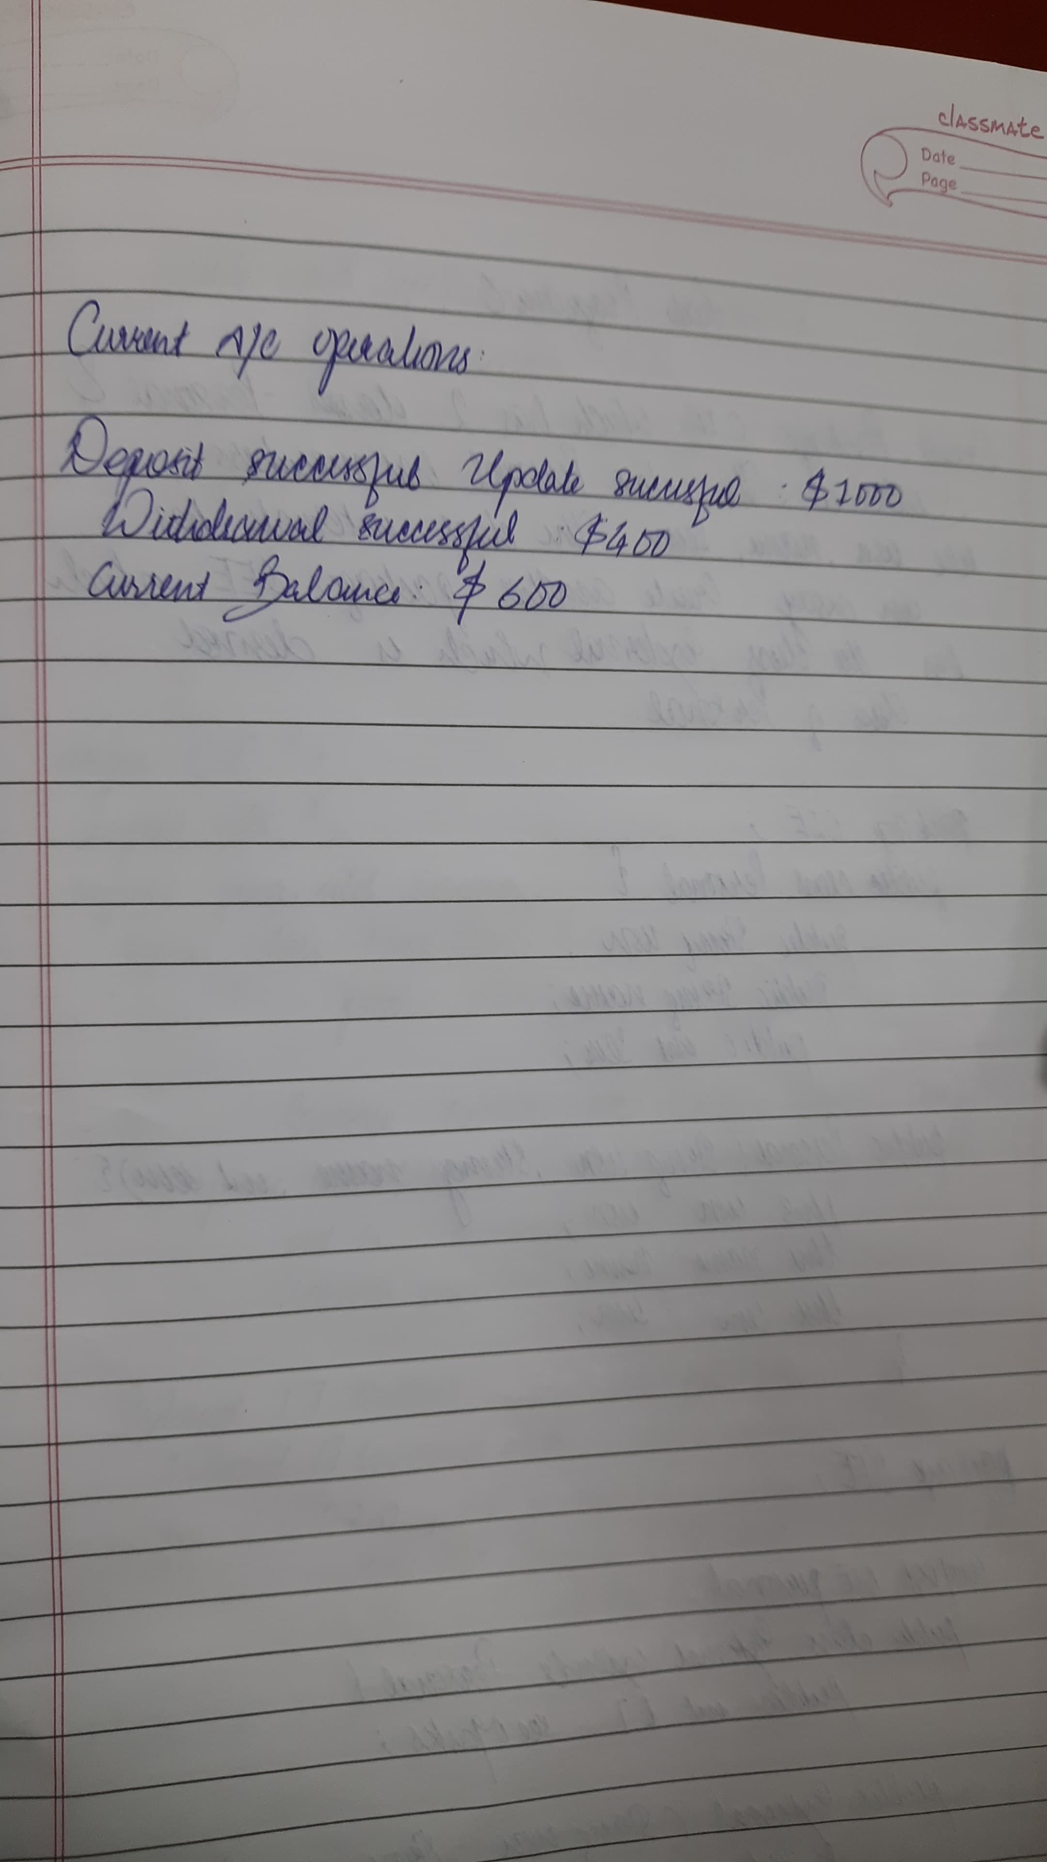

**Code:**

import java.util.Scanner;

public class Bank {

static Scanner sc = new Scanner(System.in);

Account ob1;

void createAccount() {

String customer;

int account;

String type;

int initBal;

System.out.print("Enter the customer name: ");

customer = sc.nextLine();

System.out.print("Enter account Number: ");

account = sc.nextInt();

sc.nextLine(); // Consume the newline

System.out.print("Enter Account type (Savings or Current): ");

type = sc.nextLine();

System.out.print("Enter the initial Balance: ");

initBal = sc.nextInt();

if (type.equals("Savings")) {

ob1 = new Savings(customer, account, initBal);

} else {

ob1 = new Current(customer, account, initBal);

}

}

public static void main(String[] args) {

Bank bank = new Bank();

bank.createAccount();

while (true) {

System.out.println("-------------------MENU-----------------");

System.out.println("1. Deposit 2. Withdraw");

System.out.println("3. Compute interest");

System.out.println("4. Display account details");

System.out.println("5. exit " ) ;

int choice = sc.nextInt();

switch (choice) {

case 1:

bank.ob1.deposit();

break;

case 2:

bank.ob1.withdraw();

break;

case 3:

if (bank.ob1 instanceof Savings) {

((Savings) bank.ob1).computeInterest();

} else {

System.out.println("Interest computation is only available for Savings accounts.");

}

break;

case 4:

bank.ob1.display();

break;

case 5:

break ;

default:

System.out.println("Invalid choice. Please try again.");

}

if(choice == 5) break ;

}

}

}

class Account {

String customerName;

int accountNumber;

int balance;

Account(String customer, int accountNum, int bal) {

customerName = customer;

accountNumber = accountNum;

balance = bal;

}

void deposit() {

System.out.print("Enter the amount to deposit: ");

int amt = Bank.sc.nextInt();

balance += amt;

System.out.println("Deposited: " + amt + ", New Balance: " + balance);

}

void withdraw() {

System.out.print("Enter the amount to withdraw: ");

int amt = Bank.sc.nextInt();

if (balance - amt < 0) {

System.out.println("Insufficient Balance to withdraw the given amount.");

} else {

balance -= amt;

System.out.println("Amount of " + amt + " withdrawn successfully. Current Balance is " + balance);

}

}

void display() {

System.out.println("The Balance in the account is " + balance);

}

}

class Savings extends Account {

double interestPercent;

Savings(String customer, int accountNum, int bal) {

super(customer, accountNum, bal);

System.out.print("Enter the interest percentage on the account: ");

interestPercent = Bank.sc.nextDouble();

}

void computeInterest() {

balance += balance * (interestPercent / 100);

System.out.println("Amount after applying interest is: " + balance);

}

}

class Current extends Account {

int minBalance = 1000;

Current(String customer, int accountNum, int bal) {

super(customer, accountNum, bal);

}

void withdraw() {

System.out.print("Enter the amount to withdraw: ");

int amt = Bank.sc.nextInt();

if (balance - amt < minBalance) {

System.out.println("Insufficient Balance to maintain the minimum required.");

} else {

balance -= amt;

System.out.println("Amount of " + amt + " withdrawn successfully. Current Balance is " + balance);

}

}

}

**Program 6**

Creating Packages CIE and SEE

**Algorithm:**

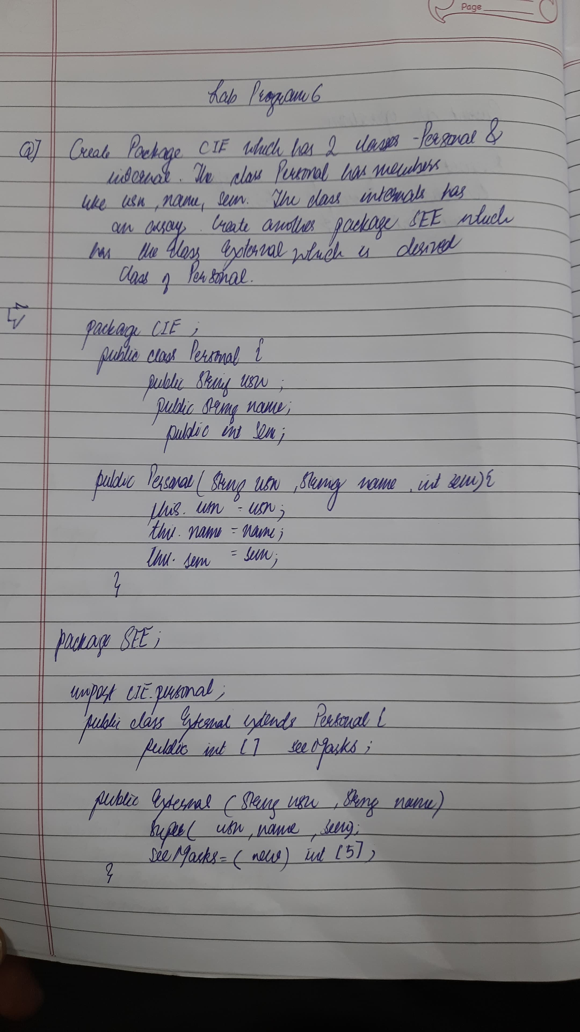

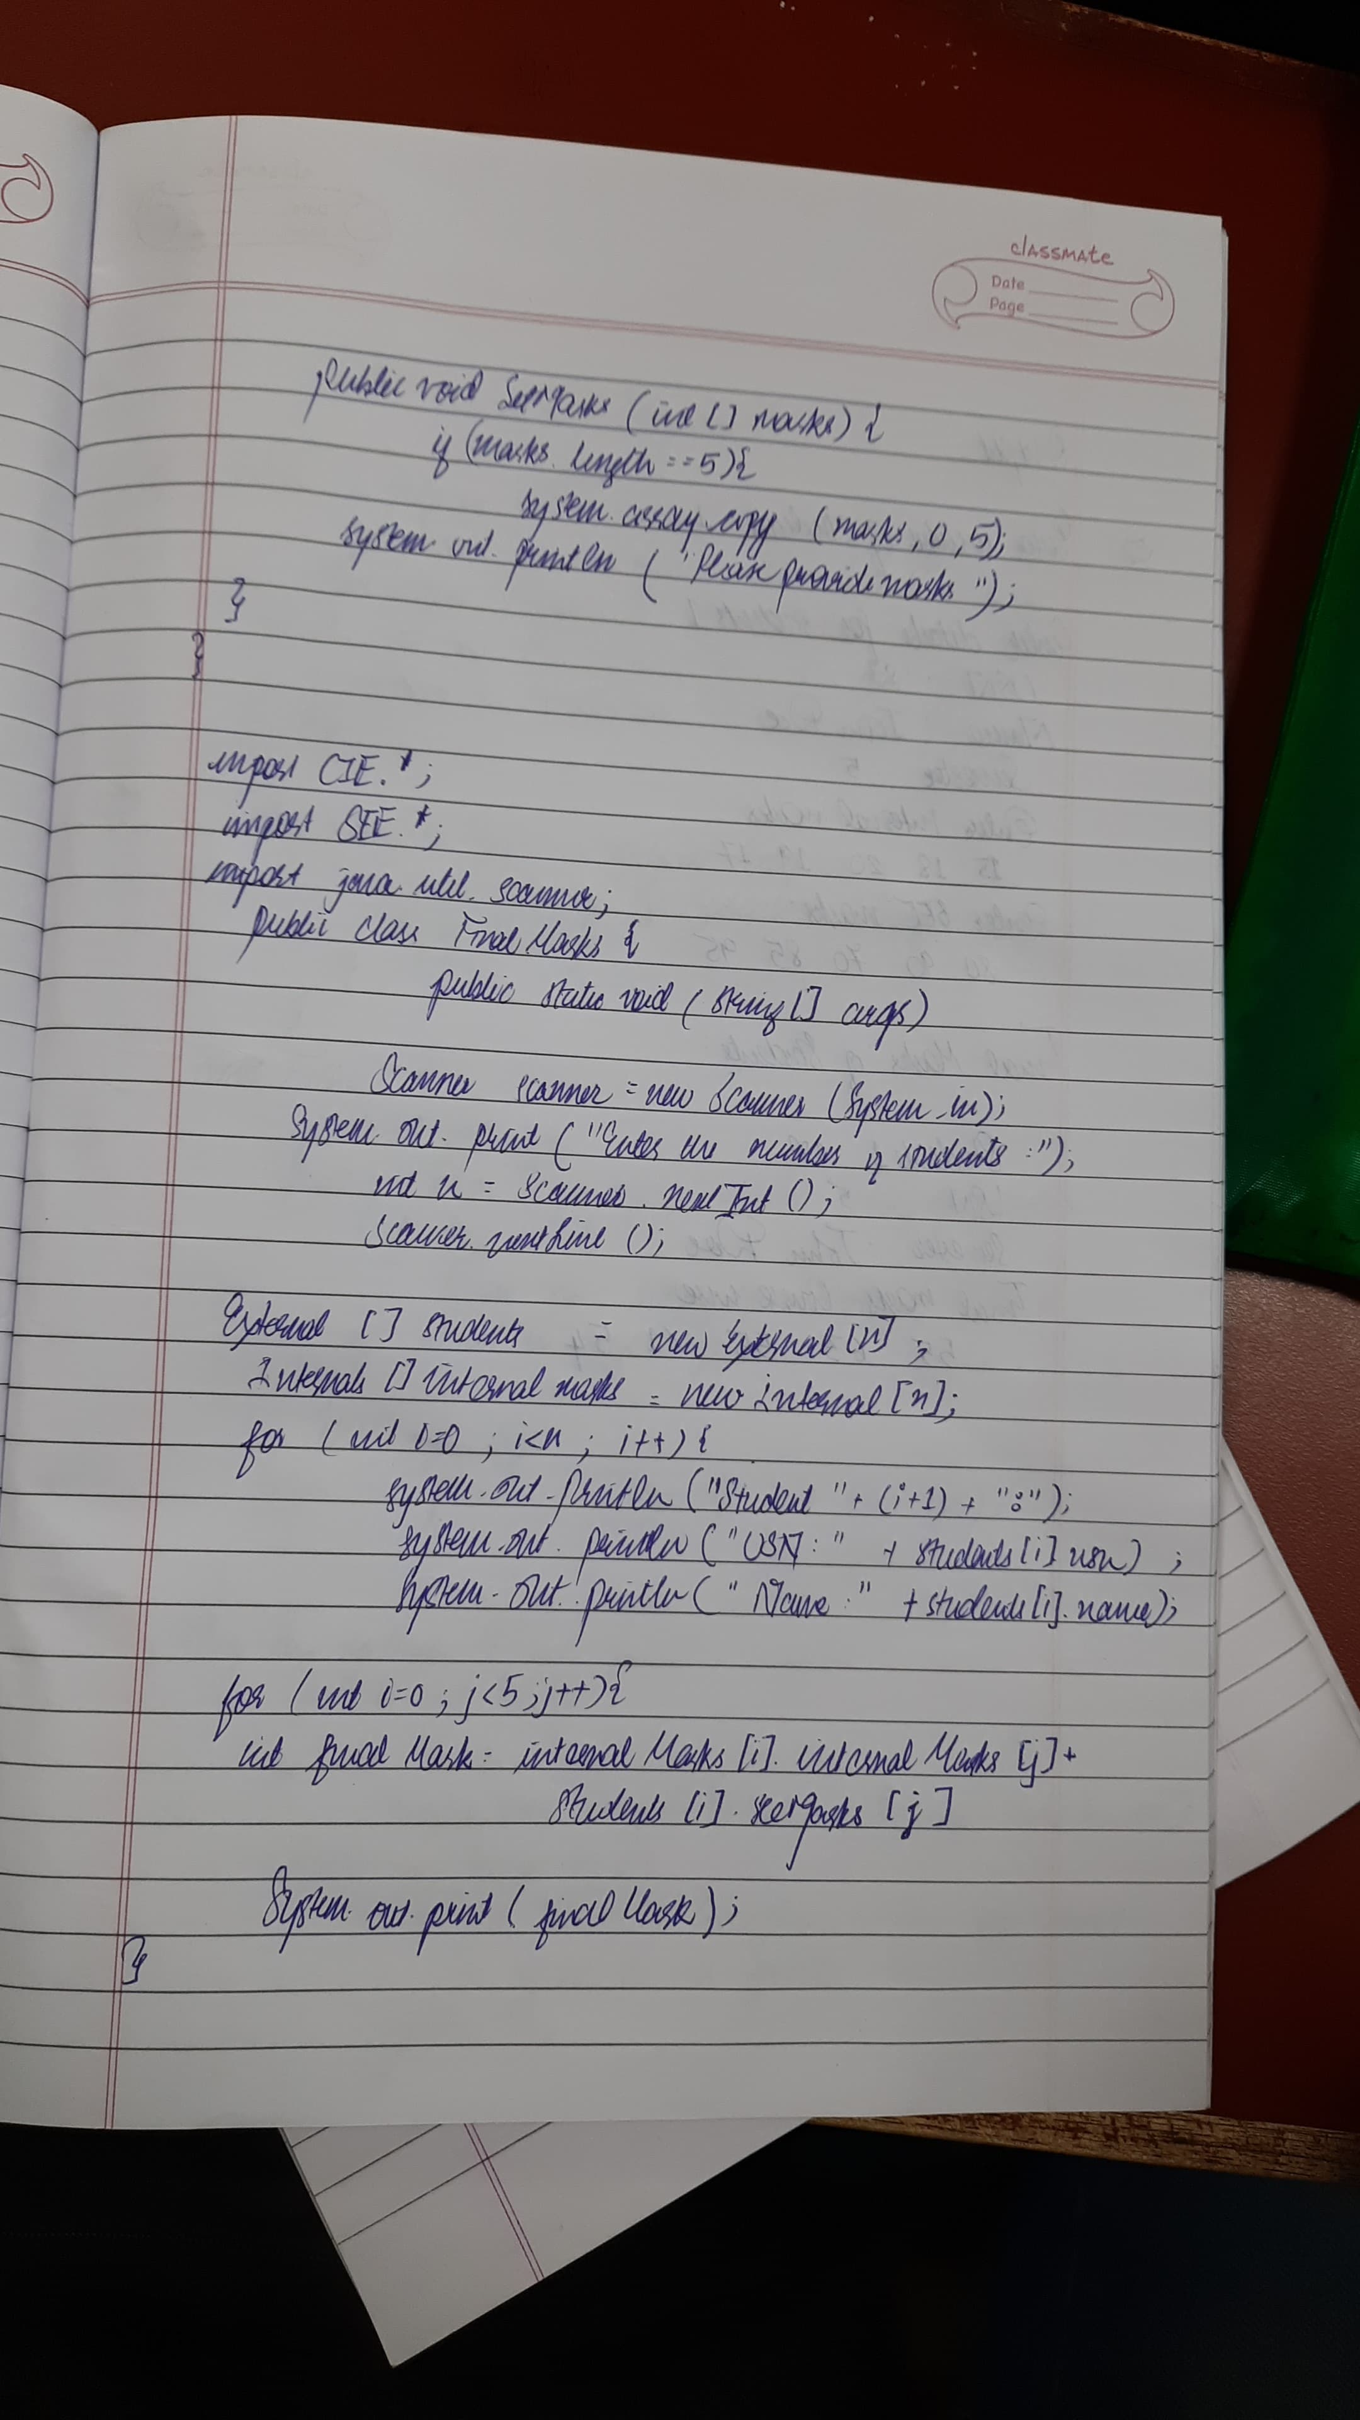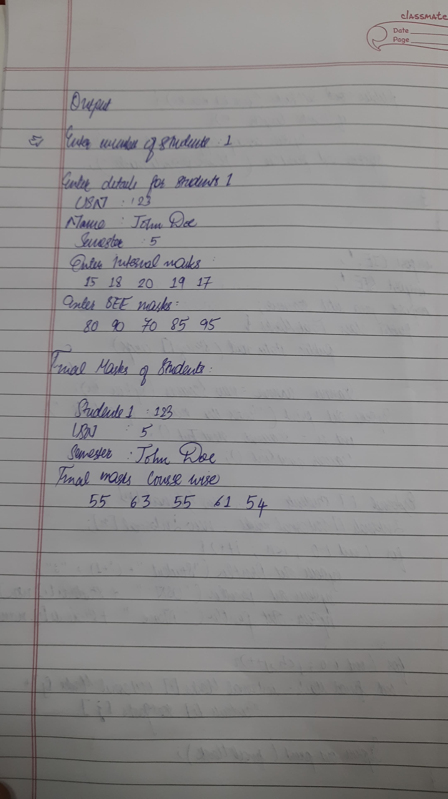

**Code:**

package CIE;

import java.util.Scanner;

public class Student {

protected String usn;

protected String name;

protected int sem;

// Method to input student details

public void inputStudentDetails() {

Scanner s = new Scanner(System.in);

System.out.print("Enter USN: ");

usn = s.nextLine();

System.out.print("Enter Name: ");

name = s.nextLine();

System.out.print("Enter Semester: ");

sem = s.nextInt();

}

// Method to display student details

public void displayStudentDetails() {

System.out.println("USN: " + usn);

System.out.println("Name: " + name);

System.out.println("Semester: " + sem);

}

}

package CIE;

import java.util.Scanner;

public class Internals extends Student {

protected int[] marks = new int[5];

// Method to input internal marks

public void inputCIEmarks() {

Scanner s = new Scanner(System.in);

System.out.println("Enter internal marks for 5 subjects:");

for (int i = 0; i < 5; i++) {

System.out.print("Enter marks for subject " + (i + 1) + ": ");

marks[i] = s.nextInt();

}

}

}

package SEE;

import CIE.Internals;

import java.util.Scanner;

public class Externals extends Internals {

protected int[] marks = new int[5]; // SEE marks

protected int[] finalMarks = new int[5]; // Final marks

// Constructor to initialize the marks arrays

public Externals() {

marks = new int[5];

finalMarks = new int[5];

}

// Method to input SEE marks

public void inputSEEmarks() {

Scanner s = new Scanner(System.in);

System.out.println("Enter SEE marks for 5 subjects:");

for (int i = 0; i < 5; i++) {

System.out.print("Enter SEE marks for subject " + (i + 1) + ": ");

marks[i] = s.nextInt();

}

}

// Method to calculate final marks (internal + external)

public void calculateFinalMarks() {

for (int i = 0; i < 5; i++) {

finalMarks[i] = marks[i] + this.marks[i]; // Final marks = internal + external

}

}

// Method to display final marks

public void displayFinalMarks() {

displayStudentDetails(); // Display student details (inherited from Student)

System.out.println("Final Marks:");

for (int i = 0; i < 5; i++) {

System.out.println("Subject " + (i + 1) + ": " + finalMarks[i]);

}

}

}

import SEE.Externals;

import java.util.Scanner;

class Main {

public static void main(String args[]) {

Scanner s = new Scanner(System.in);

// Input number of students

System.out.print("Enter number of students: ");

int n = s.nextInt();

s.nextLine(); // Consume newline

Externals[] students = new Externals[n];

// Input details for each student

for (int i = 0; i < n; i++) {

students[i] = new Externals();

System.out.println("\nEnter details for student " + (i + 1) + ":");

students[i].inputStudentDetails();

students[i].inputCIEmarks();

students[i].inputSEEmarks();

students[i].calculateFinalMarks();

}

// Display final marks for each student

System.out.println("\nDisplaying final marks for all students:");

for (int i = 0; i < n; i++) {

students[i].displayFinalMarks();

}

s.close();

}

}

**Program 7**

Handling Exceptions in Inheritance Tree

**Algorithm:**

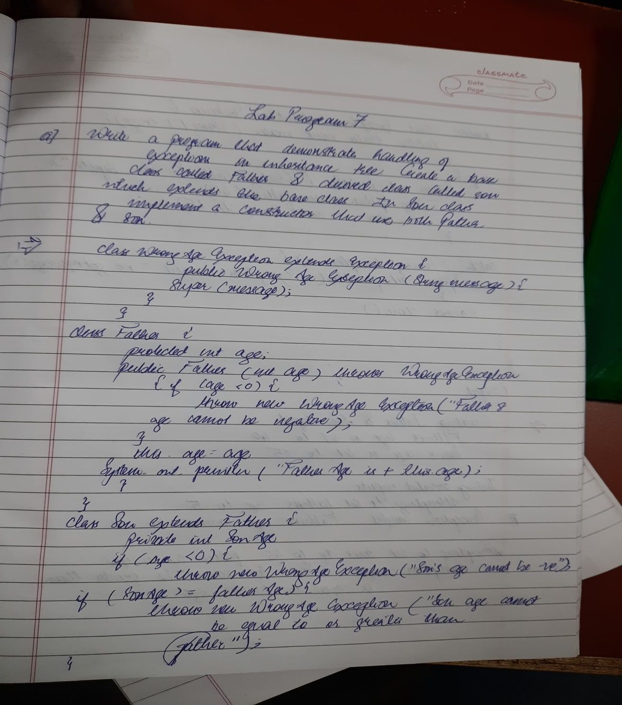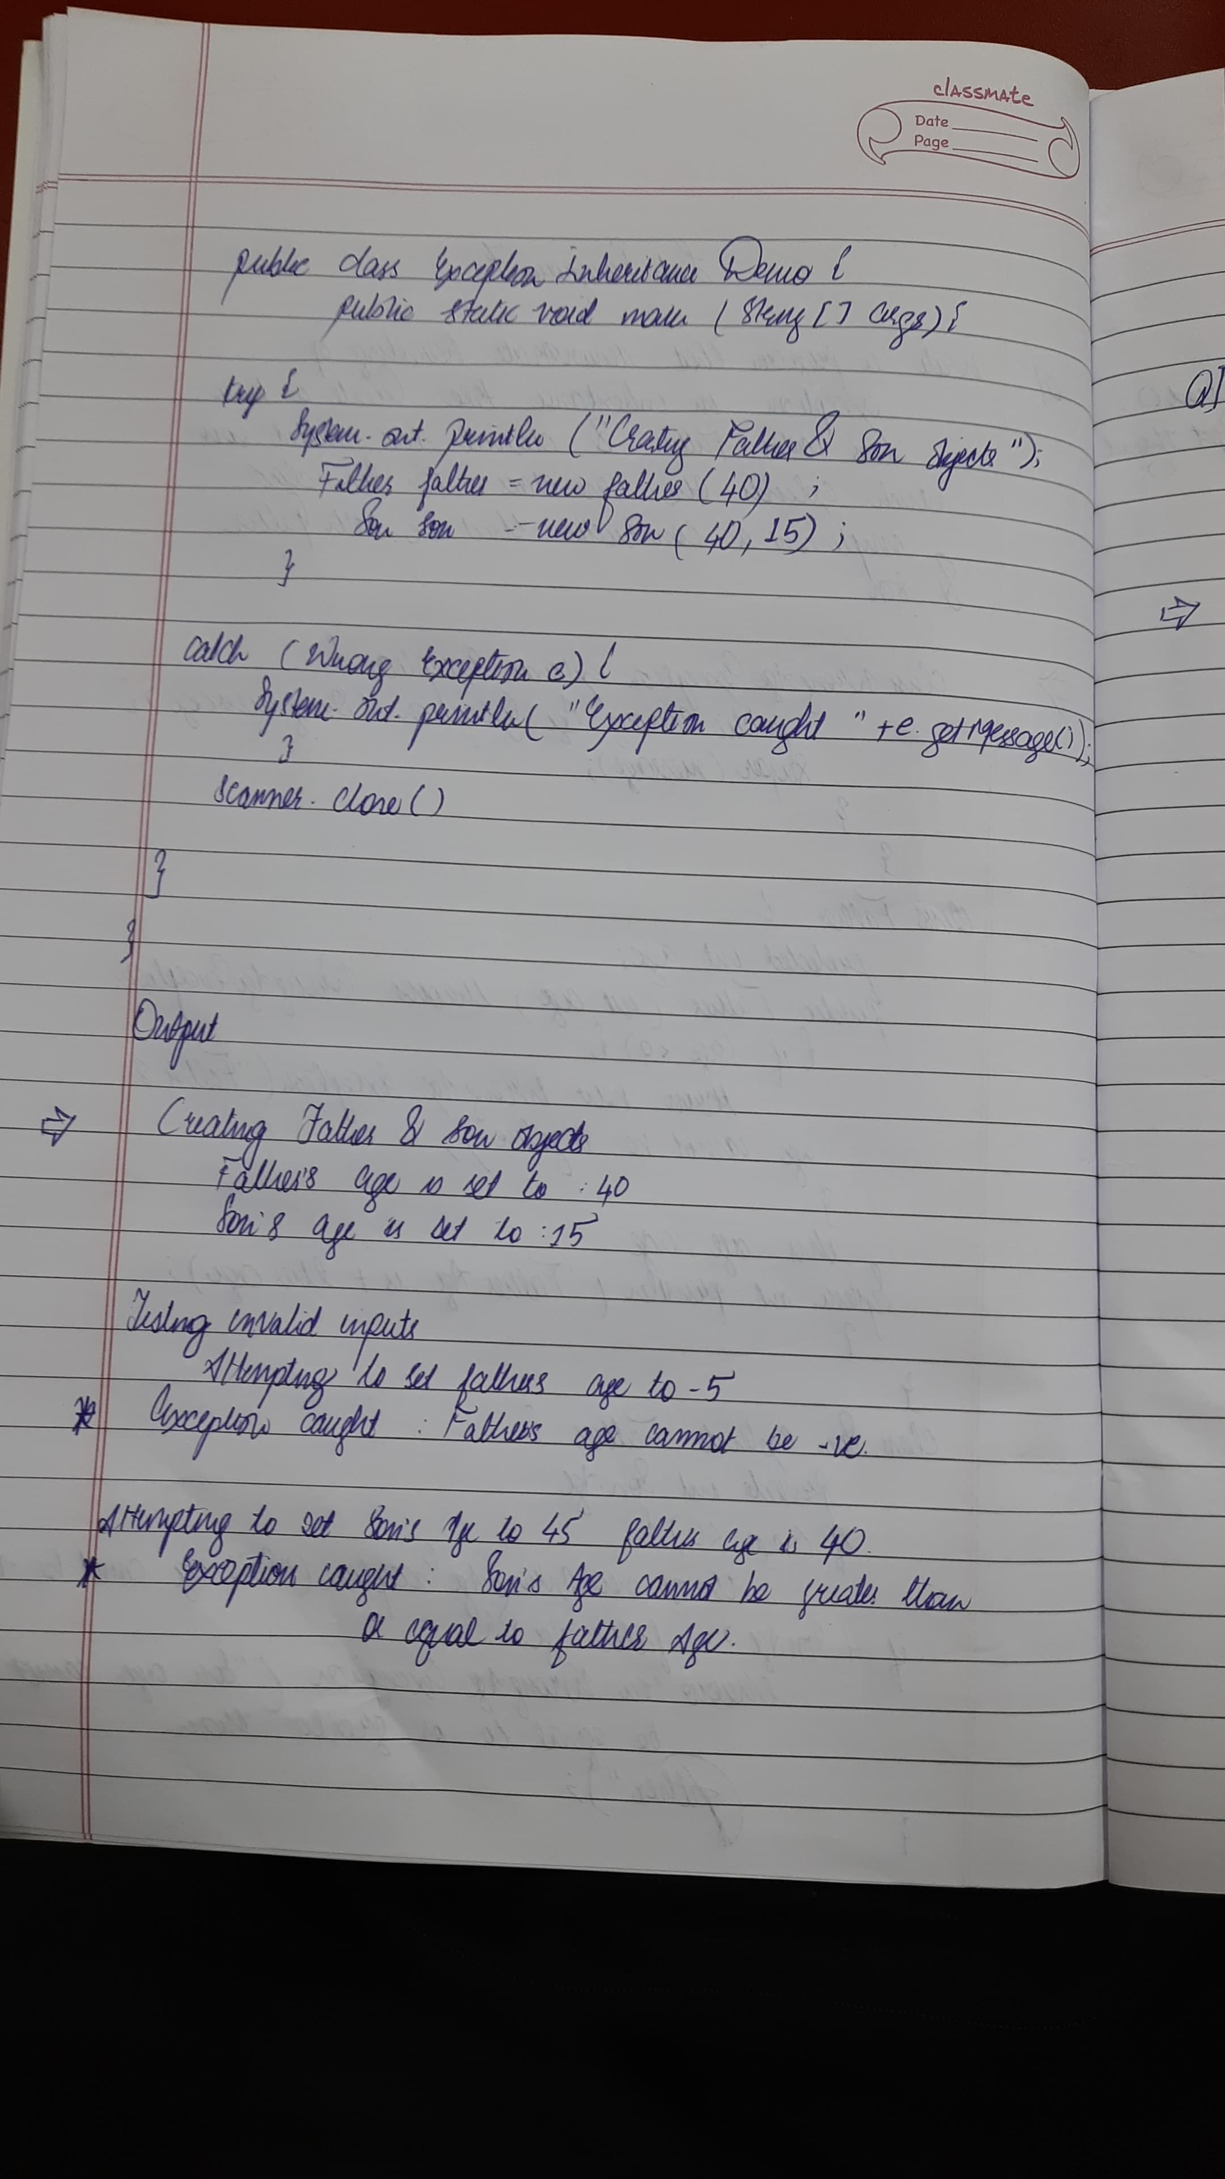

**Code:**

import java.util.Scanner;

class WrongAge extends Exception {

public WrongAge() {

super("Age Error");

}

public WrongAge(String message) {

super(message);

}

}

class InputScanner {

Scanner s = new Scanner(System.in);

}

class Father extends InputScanner {

int fatherAge;

public Father() throws WrongAge {

System.out.print("Enter Father's age: ");

fatherAge = s.nextInt();

if (fatherAge < 0) {

throw new WrongAge("Age cannot be negative");

}

}

public void display() {

System.out.println("Father's age: " + fatherAge);

}

}

class Son extends Father {

int sonAge;

public Son() throws WrongAge {

super();

System.out.print("Enter Son's age: ");

sonAge = s.nextInt();

if (sonAge >= fatherAge) {

throw new WrongAge("Son's age cannot be greater than or equal to father's age");

} else if (sonAge < 0) {

throw new WrongAge("Age cannot be negative");

}

}

public void display() {

System.out.println("Son's age: " + sonAge);

super.display(); // This calls the Father's display method

}

}

public class Exception_Handling{

public static void main(String[] args) {

try {

System.out.println("ATHARV BORIKAR 1BM23IC015");

Son son = new Son();

son.display();

} catch (WrongAge e) {

System.out.println("Exception: " + e.getMessage());

}

}

}

**Program 8**

Threads Creation

**Algorithm:**

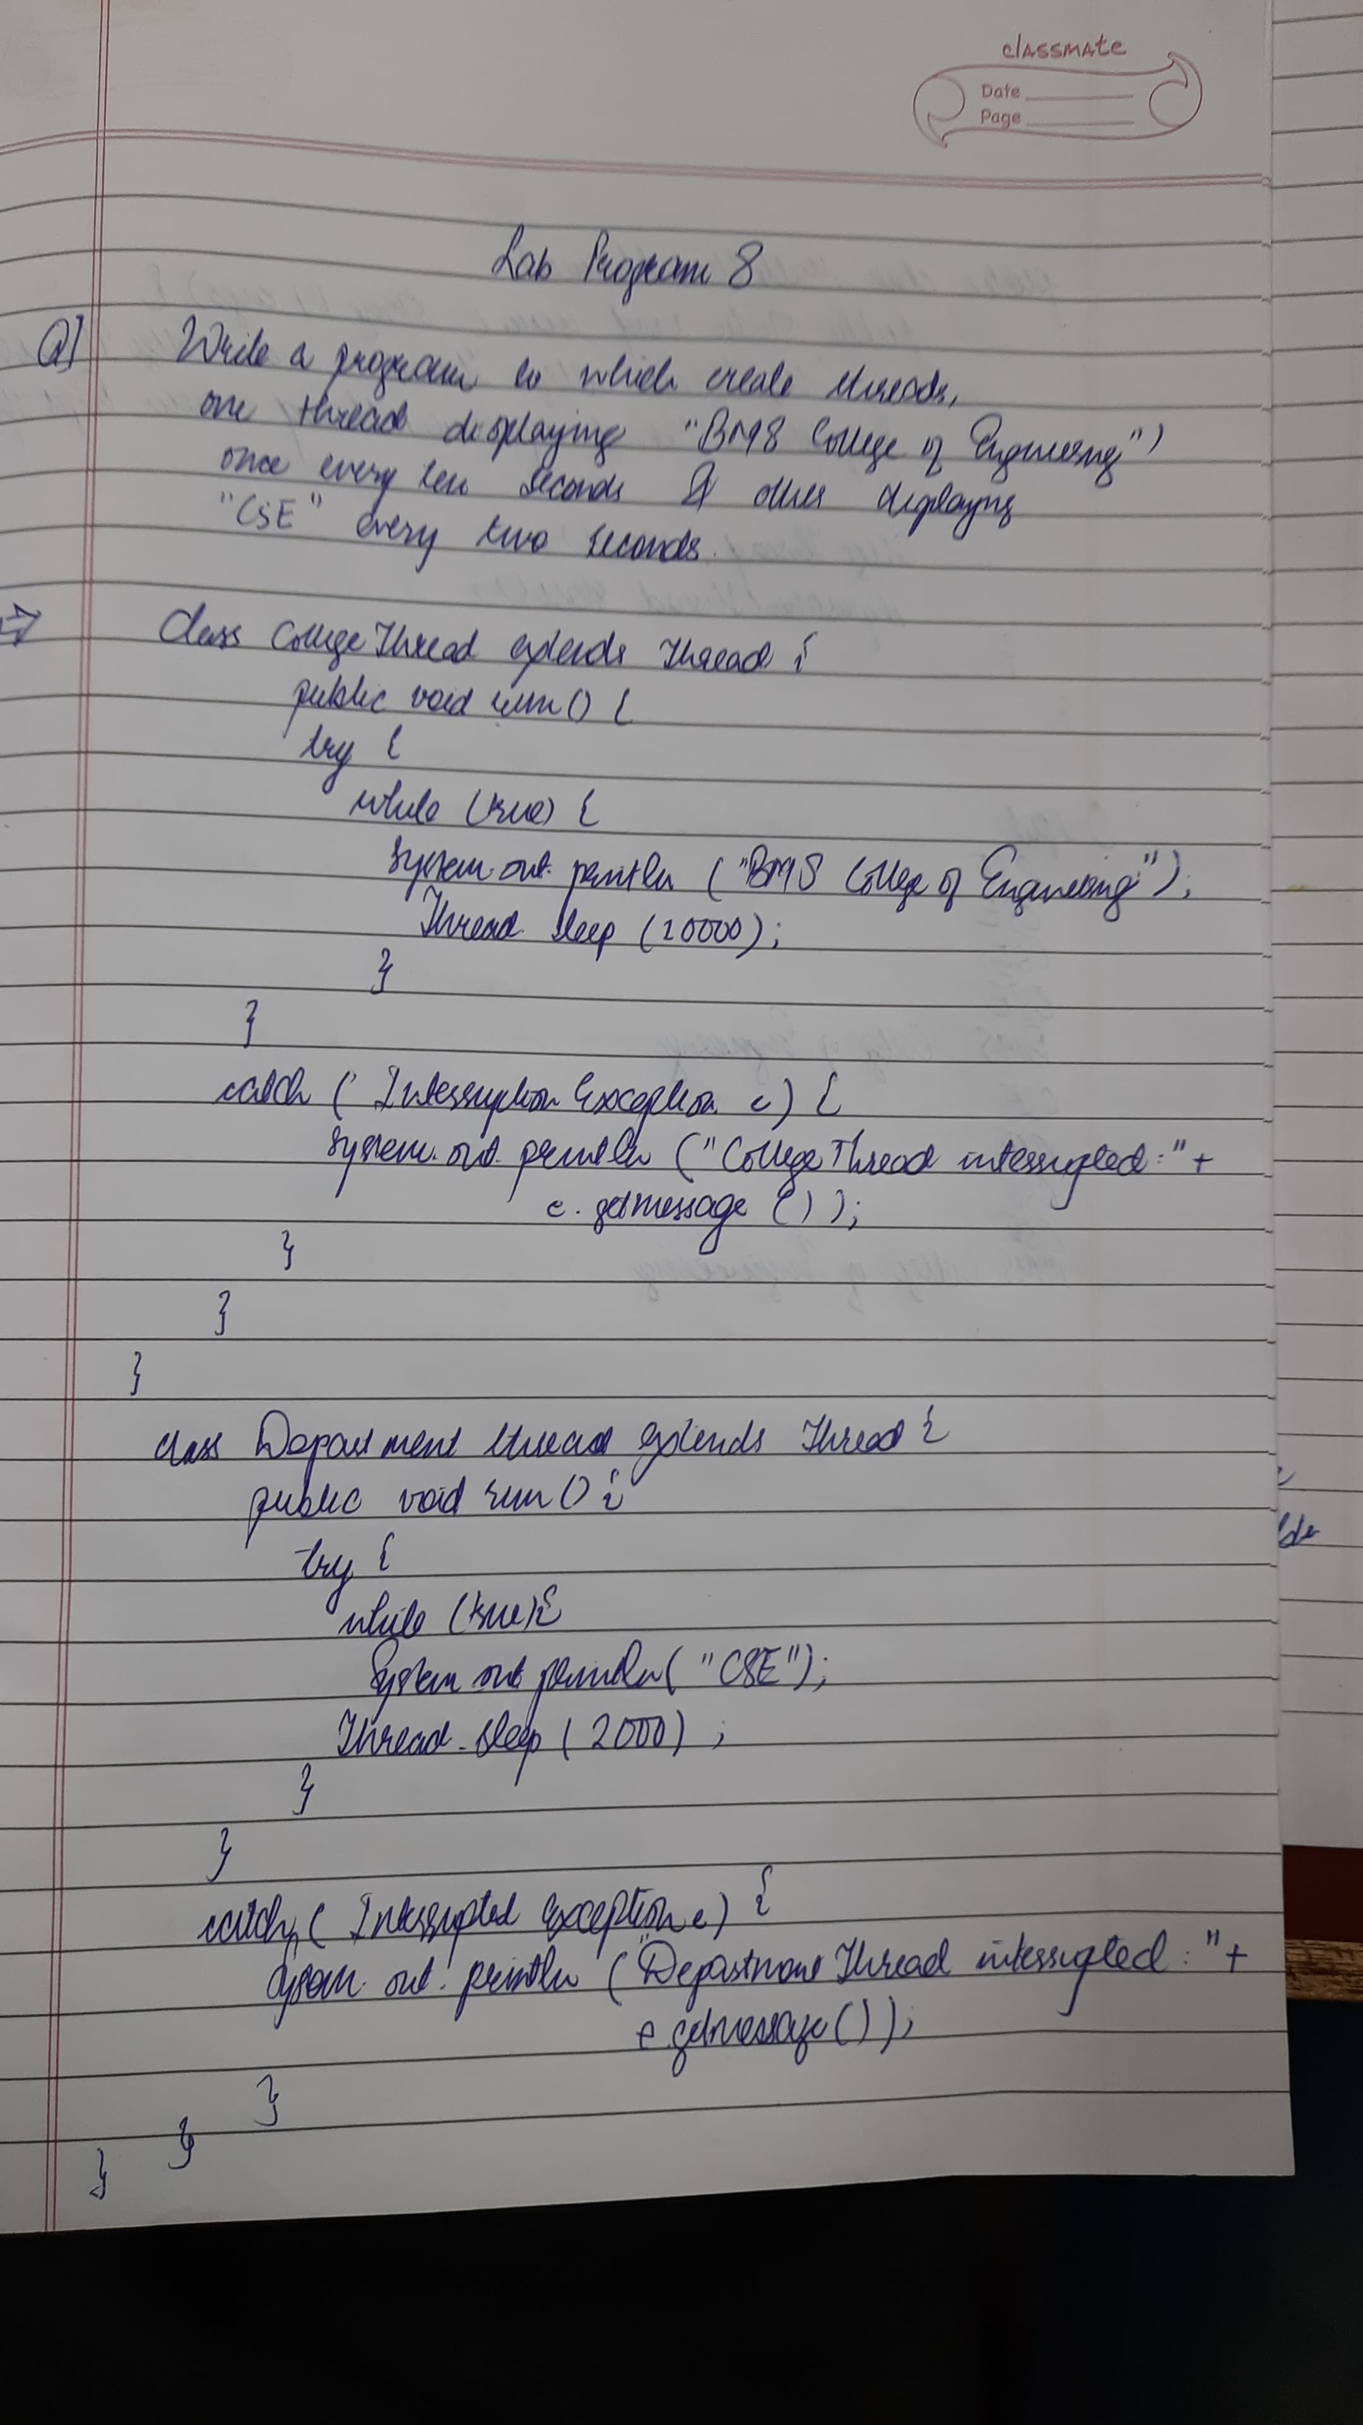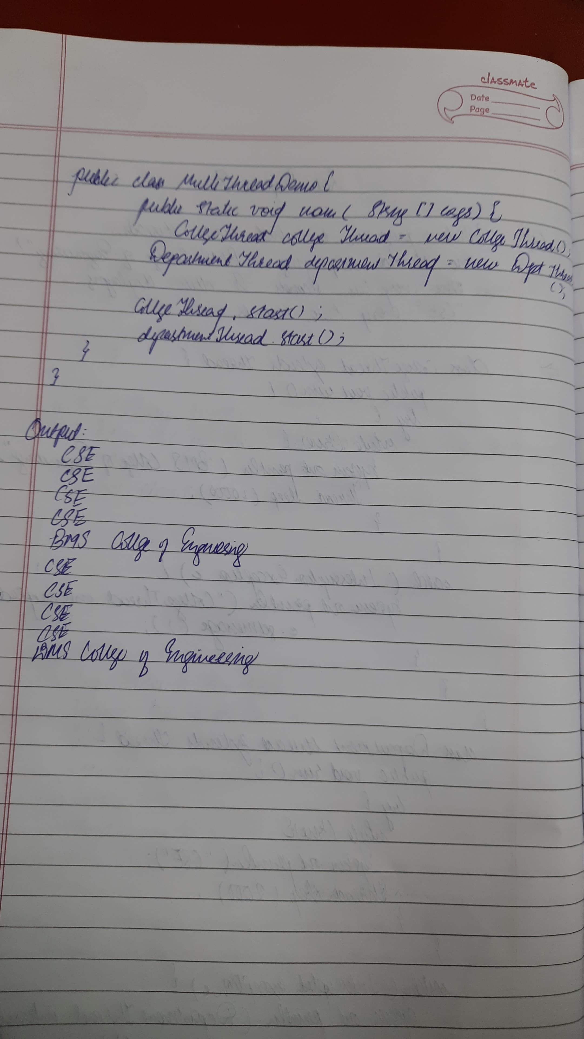

**Code:**

public class Threads {

static class BMSDisplayThread extends Thread {

public void run() {

try {

while (true) {

System.out.println("BMS College of Engineering");

Thread.sleep(10000); // Sleep for 10 seconds

}

} catch (InterruptedException e) {

System.out.println(e);

}

}

}

static class CSEDisplayThread extends Thread {

public void run() {

try {

while (true) {

System.out.println("CSE");

Thread.sleep(2000);

}

} catch (InterruptedException e) {

System.out.println(e);

}

}

}

public static void main(String[] args) {

BMSDisplayThread bmsThread = new BMSDisplayThread();

CSEDisplayThread cseThread = new CSEDisplayThread();

System.out.println("ATHARV BORIKAR");

System.out.println("1BM23IC015");

bmsThread.start();

cseThread.start();

}

}

**Program 9**

User Interface Creation

**Algorithm:**

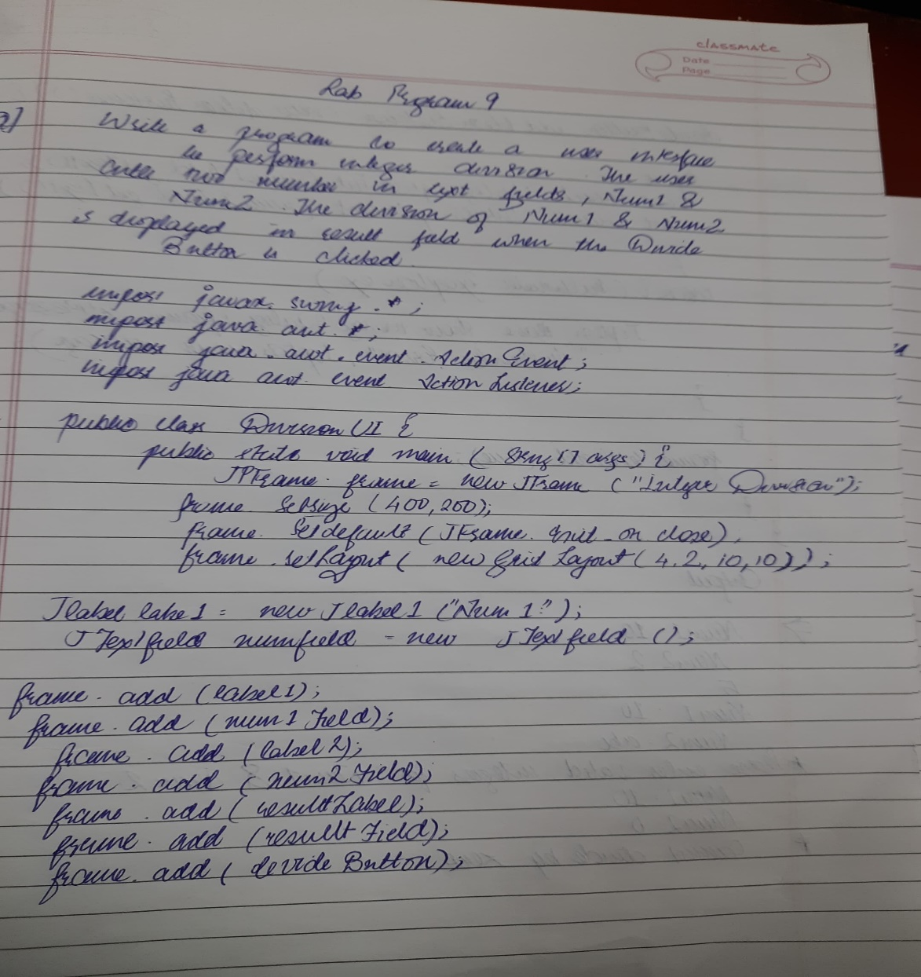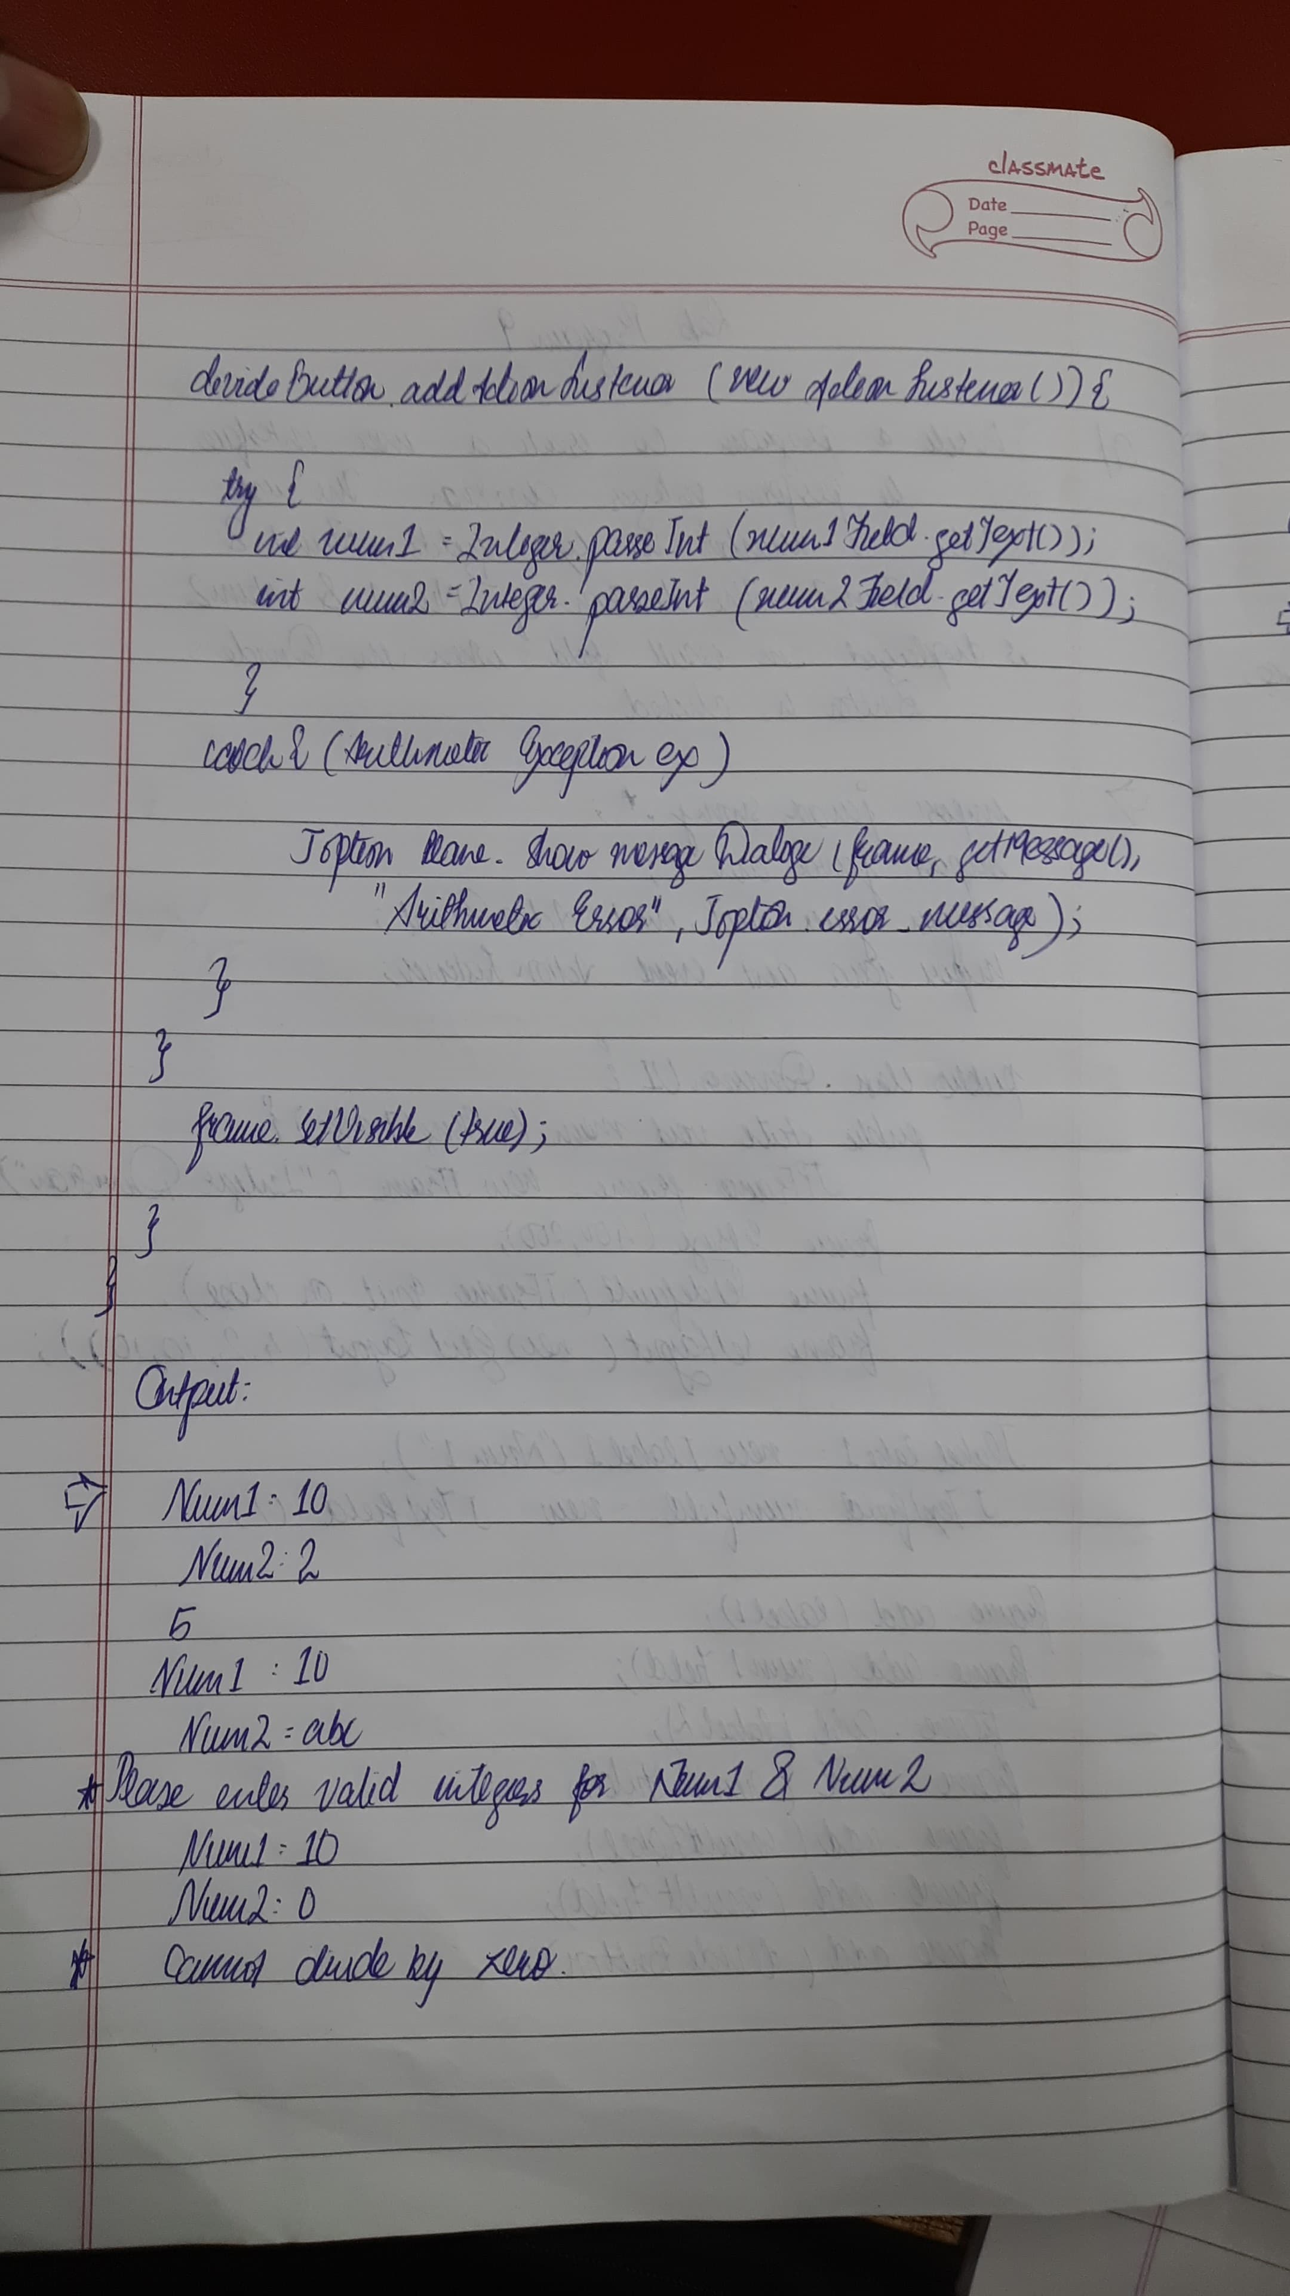

**Code:**

import javax.swing.*;

import java.awt.*;

import java.awt.event.*;

class SwingDemo {

SwingDemo() {

JFrame jfrm = new JFrame("Divider App");

jfrm.setSize(275, 200);

jfrm.setLayout(new FlowLayout());

jfrm.setDefaultCloseOperation(JFrame.EXIT_ON_CLOSE);

JLabel jlab = new JLabel("Enter the divisor and dividend:");

JTextField ajtf = new JTextField(8);

JTextField bjtf = new JTextField(8);

JButton button = new JButton("Calculate");

JLabel err = new JLabel();

JLabel alab = new JLabel();

JLabel blab = new JLabel();

JLabel anslab = new JLabel();

jfrm.add(err);

jfrm.add(jlab);

jfrm.add(ajtf);

jfrm.add(bjtf);

jfrm.add(button);

jfrm.add(alab);

jfrm.add(blab);

jfrm.add(anslab);

button.addActionListener(new ActionListener() {

public void actionPerformed(ActionEvent evt) {

try {

int a = Integer.parseInt(ajtf.getText());

int b = Integer.parseInt(bjtf.getText());

int ans = a / b;

alab.setText("A = " + a);

blab.setText("B = " + b);

anslab.setText("Ans = " + ans);

err.setText("");

} catch (NumberFormatException e) {

alab.setText("");

blab.setText("");

anslab.setText("");

err.setText("Enter Only Integers!");

} catch (ArithmeticException e) {

alab.setText("");

blab.setText("");

anslab.setText("");

err.setText("B should be NON zero!");

}

}

});

jfrm.setVisible(true);

}

public static void main(String args[]) {

SwingUtilities.invokeLater(new Runnable() {

public void run() {

new SwingDemo();

}

});

}

} import javax.swing.*;

import java.awt.*;

import java.awt.event.*;

class SwingDemo {

SwingDemo() {

JFrame jfrm = new JFrame("Divider App");

jfrm.setSize(275, 200);

jfrm.setLayout(new FlowLayout());

jfrm.setDefaultCloseOperation(JFrame.EXIT_ON_CLOSE);

JLabel jlab = new JLabel("Enter the divisor and dividend:");

JTextField ajtf = new JTextField(8);

JTextField bjtf = new JTextField(8);

JButton button = new JButton("Calculate");

JLabel err = new JLabel();

JLabel alab = new JLabel();

JLabel blab = new JLabel();

JLabel anslab = new JLabel();

jfrm.add(err);

jfrm.add(jlab);

jfrm.add(ajtf);

jfrm.add(bjtf);

jfrm.add(button);

jfrm.add(alab);

jfrm.add(blab);

jfrm.add(anslab);

button.addActionListener(new ActionListener() {

public void actionPerformed(ActionEvent evt) {

try {

int a = Integer.parseInt(ajtf.getText());

int b = Integer.parseInt(bjtf.getText());

int ans = a / b;

alab.setText("A = " + a);

blab.setText("B = " + b);

anslab.setText("Ans = " + ans);

err.setText("");

} catch (NumberFormatException e) {

alab.setText("");

blab.setText("");

anslab.setText("");

err.setText("Enter Only Integers!");

} catch (ArithmeticException e) {

alab.setText("");

blab.setText("");

anslab.setText("");

err.setText("B should be NON zero!");

}

}

});

jfrm.setVisible(true);

}

public static void main(String args[]) {

SwingUtilities.invokeLater(new Runnable() {

public void run() {

new SwingDemo();

}

});

}

}

**Program 10 a)**

Demonstrating IPC

**Algorithm:**

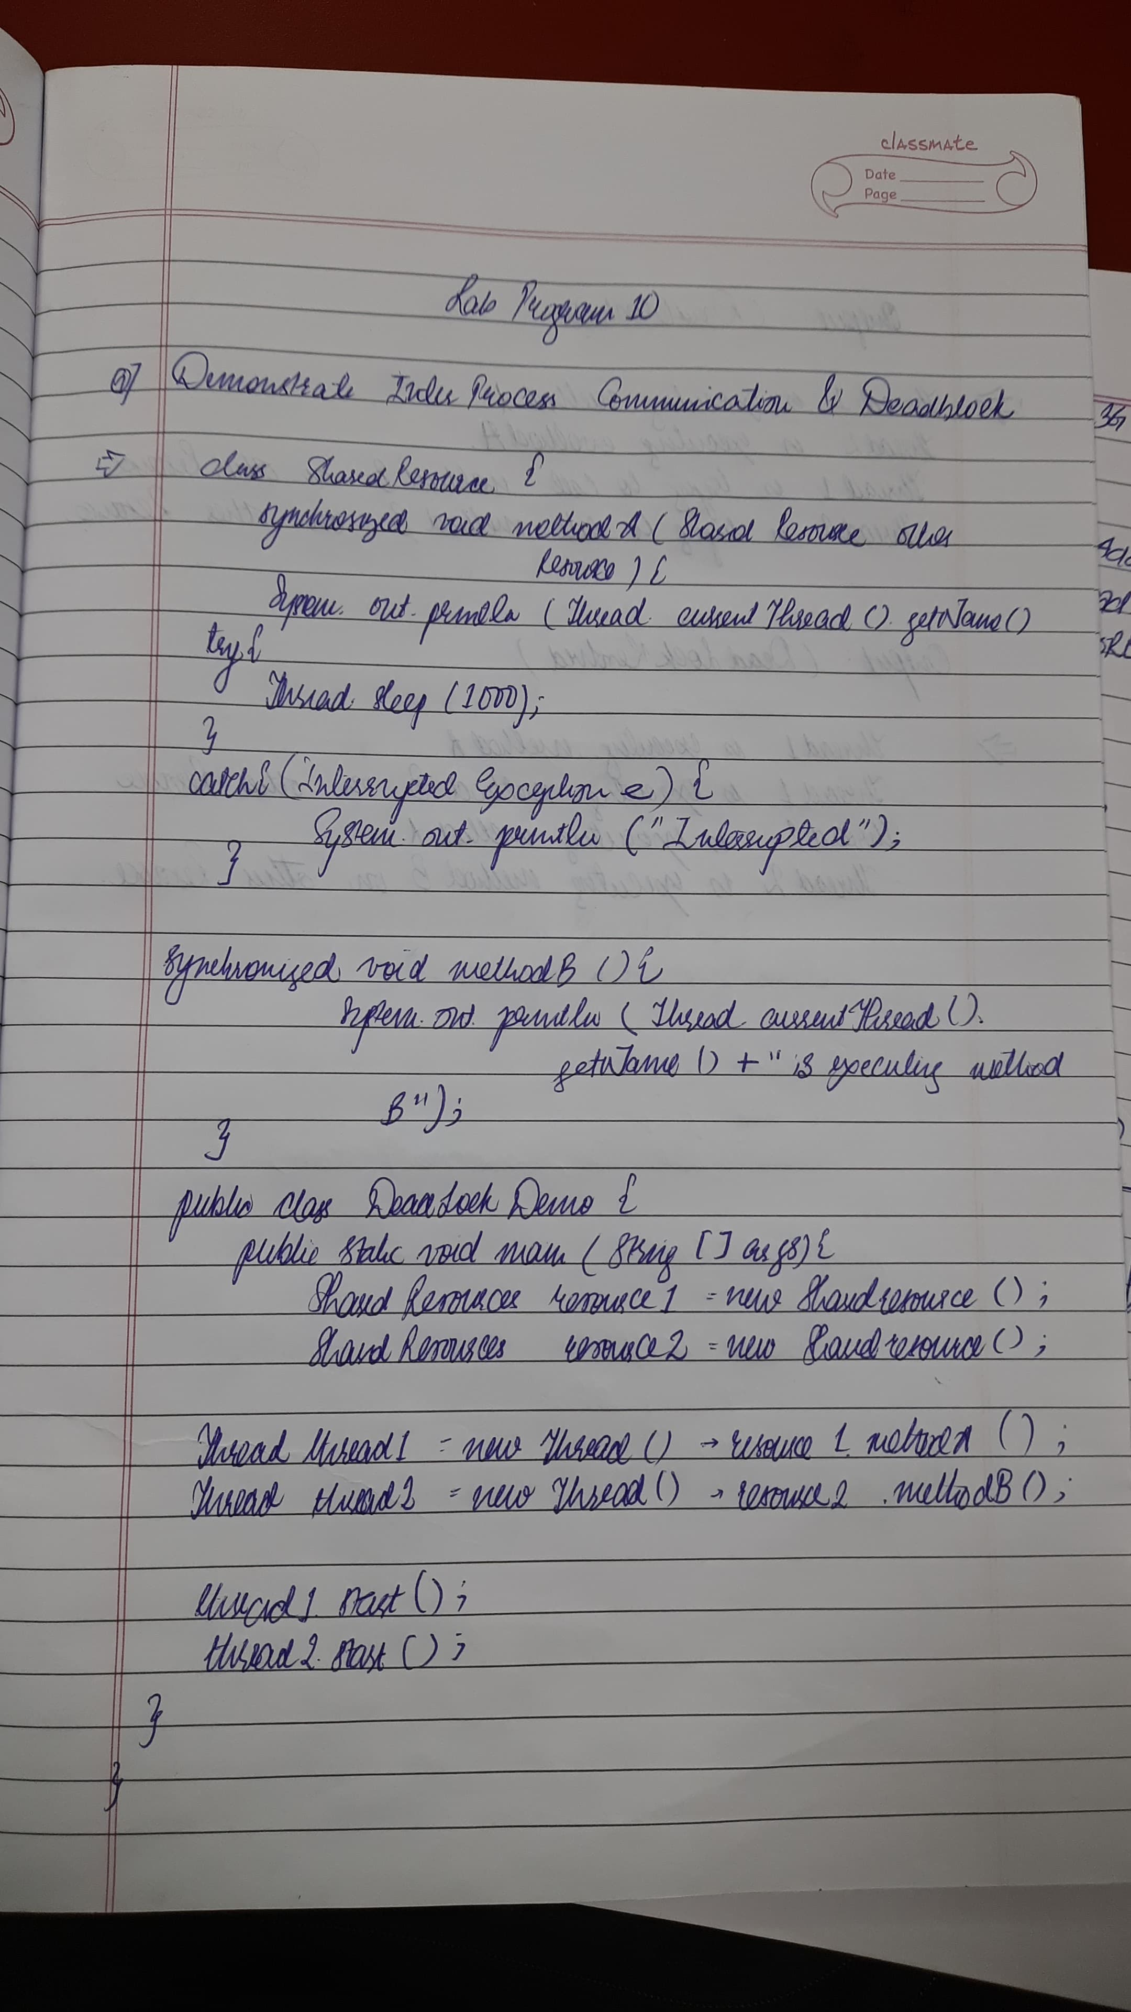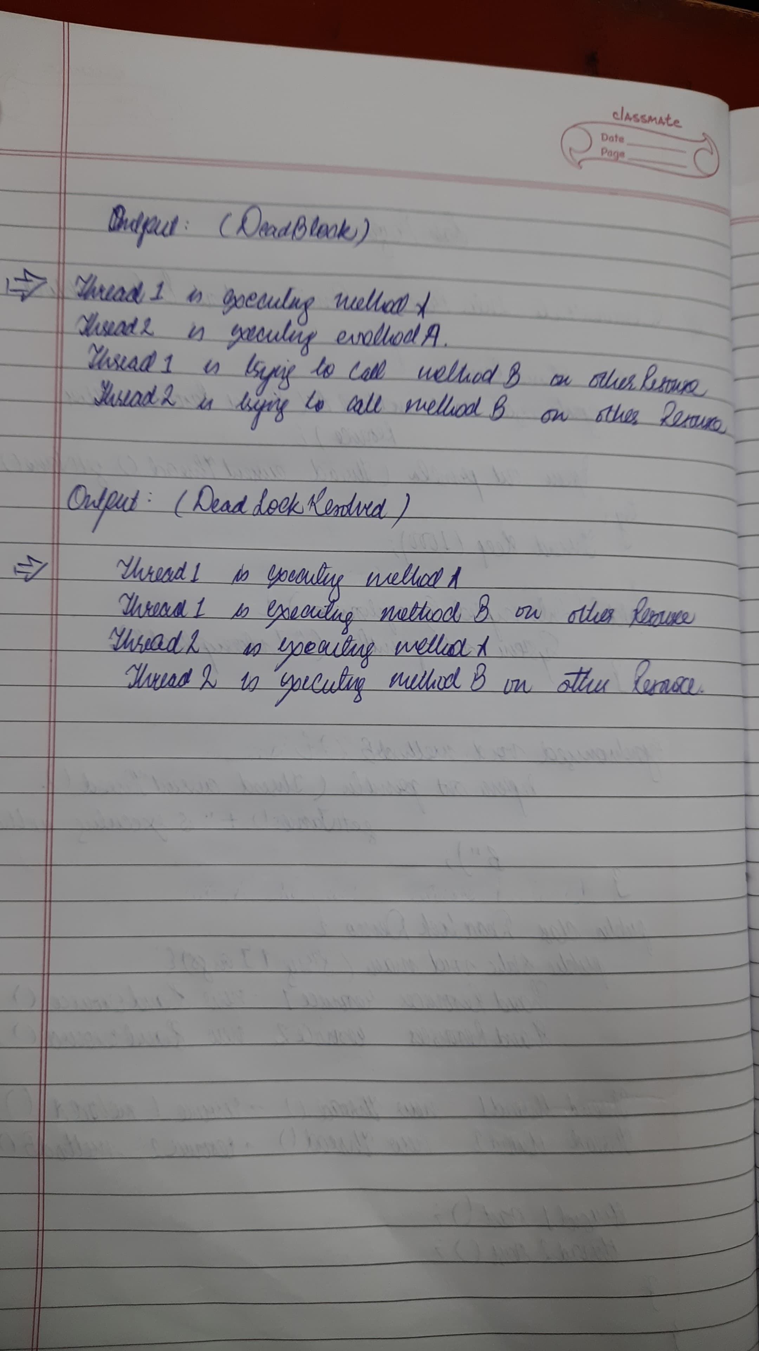

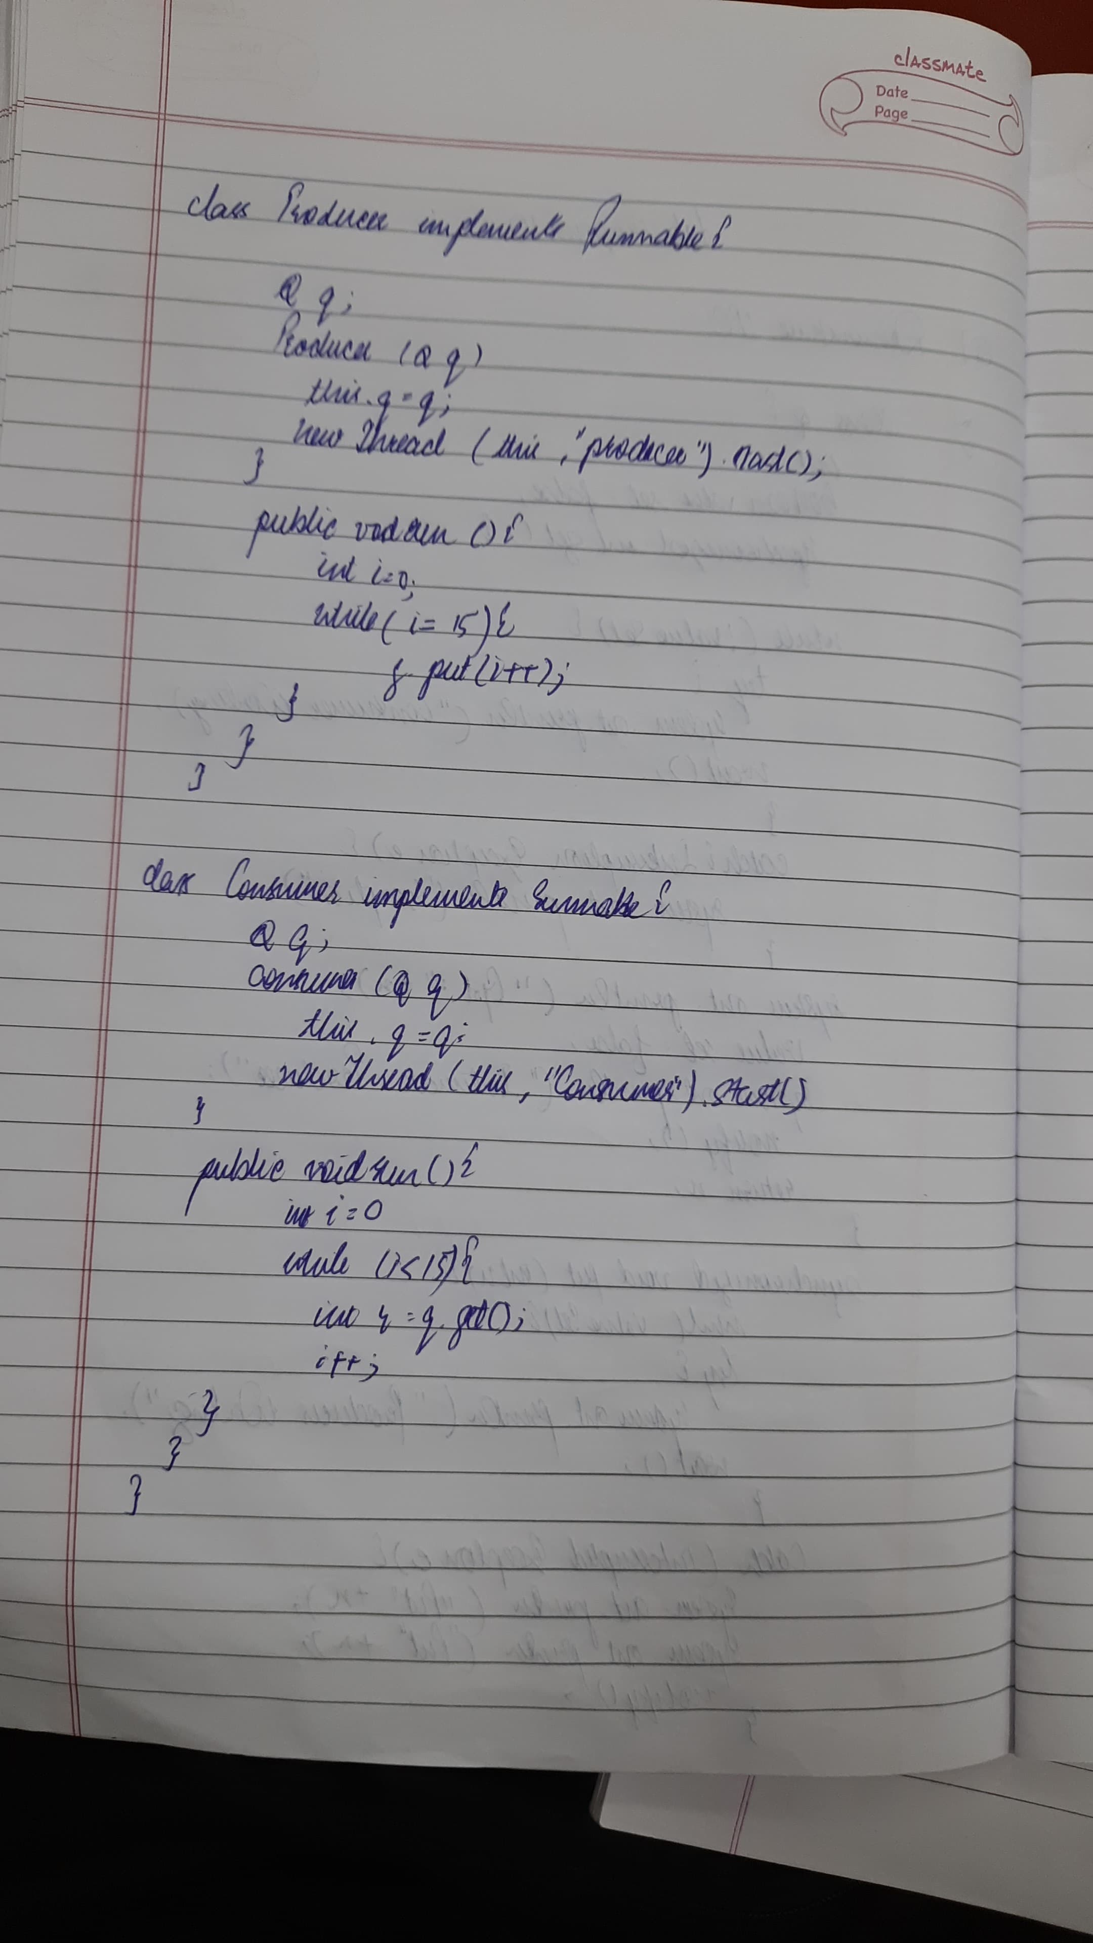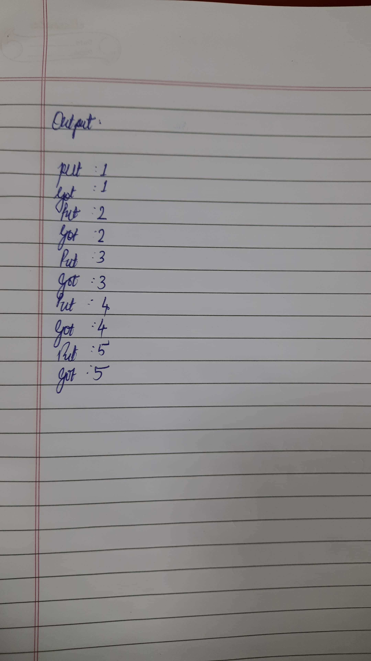

**Code:**

class Q {

int n;

boolean valueSet = false;

synchronized int get() {

while(!valueSet)

try {

System.out.println("\nConsumer waiting\n");

wait();

} catch(InterruptedException e) {

System.out.println("InterruptedException caught");

}

System.out.println("Got: " + n);

valueSet = false;

System.out.println("\nIntimate Producer\n");

notify();

return n;

}

synchronized void put(int n) {

while(valueSet)

try {

System.out.println("\nProducer waiting\n");

wait();

} catch(InterruptedException e) {

System.out.println("InterruptedException caught");

}

this.n = n;

valueSet = true;

System.out.println("Put: " + n);

System.out.println("\nIntimate Consumer\n");

notify();

}

}

class Producer implements Runnable {

Q q;

Producer(Q q) {

this.q = q;

new Thread(this, "Producer").start();

}

public void run() {

int i = 0;

while(i<15) {

q.put(i++);

}

}

}

class Consumer implements Runnable {

Q q;

Consumer(Q q) {

this.q = q;

new Thread(this, "Consumer").start();

}

public void run() {

int i=0;

while(i<15) {

int r=q.get();

System.out.println("consumed:"+r);

i++;

}

}

}

class IPC {

public static void main(String args[]) {

Q q = new Q();

System.out.println("ATHARV BORIKAR 1BM23IC015");

new Producer(q);

new Consumer(q);

System.out.println("Press Control-C to stop.");

}

}

**Program 10 b)**

Demonstrating Deadlock

**Algorithm:**

**Code:**

import java.util.*;

class A {

synchronized void foo(B b) {

String name = Thread.currentThread().getName();

System.out.println(name + " entered == A.foo");

try {

Thread.sleep(1000);

} catch (Exception e) {

System.out.println("A Interrupted");

}

System.out.println(name + " trying to call B.last");

b.last();

}

synchronized void last() {

System.out.println("Inside A.last");

}

}

class B {

synchronized void bar(A a) {

String name = Thread.currentThread().getName();

System.out.println(name + " entered B.bar");

try {

Thread.sleep(1000);

} catch (Exception e) {

System.out.println("B Interrupted");

}

System.out.println(name + " trying to call A.last");

a.last();

}

synchronized void last() {

System.out.println("Inside B.last");

}

}

class Deadlock implements Runnable {

A a = new A();

B b = new B();

Deadlock() {

Thread.currentThread().setName("MainThread");

Thread t = new Thread(this, "RacingThread");

t.start();

a.foo(b);

System.out.println("Back in main thread");

}

public void run() {

b.bar(a);

System.out.println("Back in other thread");

}

public static void main(String args[]) {

new Deadlock();

}

}